[1 Introduction to SAP 3](#_Toc35857132)

[1.1 The SAP System 3](#_Toc35857133)

[1.2 Basic concepts 8](#_Toc35857134)

[1.3 Organization 10](#_Toc35857135)

[1.3.1 All organization levels 10](#_Toc35857136)

[1.3.2 Organization in Materials Management 12](#_Toc35857137)

[1.3.3 Organization in Sales 13](#_Toc35857138)

[1.3.4 Organization in production 13](#_Toc35857139)

[1.3.5 Organization in Financial Accounting 14](#_Toc35857140)

[1.4 Master data 15](#_Toc35857141)

[1.4.1 Customer master contains the following views: 15](#_Toc35857142)

[1.4.2 Vendor master 15](#_Toc35857143)

[1.4.3 Material master 15](#_Toc35857144)

[2 Working with SAP 17](#_Toc35857145)

[2.1 SAP via VPN 17](#_Toc35857146)

[2.1.1 Install VPN 17](#_Toc35857147)

[2.1.2 Install SAP GUI: 17](#_Toc35857148)

[2.1.3 Store the SAPUILandscape.xml 18](#_Toc35857149)

[2.1.4 Run VPN 18](#_Toc35857150)

[2.1.5 Assign the SAPUILandscape.xml 18](#_Toc35857151)

[2.1.6 Logins 19](#_Toc35857152)

[2.2 Login to the system 20](#_Toc35857153)

[2.3 Change password 22](#_Toc35857154)

[2.4 Log out 23](#_Toc35857155)

[2.5 Close GUI Window 24](#_Toc35857156)

[2.6 Settings 24](#_Toc35857157)

[2.7 New GUI Window, Stop transaction 26](#_Toc35857158)

[2.8 The system information 26](#_Toc35857159)

[2.9 Go forward 27](#_Toc35857160)

[2.10 Status 27](#_Toc35857161)

[2.11 System messages 28](#_Toc35857162)

[2.12 The menu bar 29](#_Toc35857163)

[2.13 Navigation 29](#_Toc35857164)

[2.14 Transaction codes 30](#_Toc35857165)

[2.14.1 What are transaction codes 30](#_Toc35857166)

[2.14.2 Search transaction codes 31](#_Toc35857167)

[2.14.3 Enter transaction codes 32](#_Toc35857168)

[2.14.4 Exit transaction 33](#_Toc35857169)

[2.15 SAP GUI modes 33](#_Toc35857170)

[2.15.1 Open mode and application simultaneously 34](#_Toc35857171)

[2.15.2 Change modes 34](#_Toc35857172)

[2.16 Favorites 35](#_Toc35857173)

[2.17 Working with Fields 37](#_Toc35857174)

[2.18 Function keys 38](#_Toc35857175)

[2.19 User Data 39](#_Toc35857176)

[2.20 Help functions 40](#_Toc35857177)

[2.20.1 Application help 41](#_Toc35857178)

[2.20.2 SAP Library 41](#_Toc35857179)

[2.21 Help for fields 41](#_Toc35857180)

[2.22 Help for input values 41](#_Toc35857181)

# Introduction to SAP

## The SAP System

SAP = systems, applications, products

Five former [IBM](http://de.wikipedia.org/wiki/IBM) employees ([Claus Wellenreuther](http://de.wikipedia.org/w/index.php?title=Claus_Wellenreuther&action=edit&redlink=1), [Hans-Werner Hector](http://de.wikipedia.org/wiki/Hans-Werner_Hector), [Klaus Tschira](http://de.wikipedia.org/wiki/Klaus_Tschira), [Dietmar Hopp](http://de.wikipedia.org/wiki/Dietmar_Hopp) and [Hasso Plattner](http://de.wikipedia.org/wiki/Hasso_Plattner)) founded the company Systemanalyse und Programmentwicklung in [Weinheim](http://de.wikipedia.org/wiki/Weinheim) in 1972.

They developed programs that made payroll accounting and bookkeeping via [mainframe computers](http://de.wikipedia.org/wiki/Gro%C3%9Frechner) possible. Instead of storing the data mechanically on [punched cards,](http://de.wikipedia.org/wiki/Lochkarte) as with their ex-employer IBM, they relied on screen input. They therefore referred to their software as a [real-time](http://de.wikipedia.org/wiki/Echtzeit) system. For this reason an R was always found in the name of the products until the late 90s. The first version of the software was developed in the [data center of](http://de.wikipedia.org/wiki/Rechenzentrum) the first customer, the [nylon fiber plant](http://de.wikipedia.org/wiki/Nylon) of [Imperial Chemical Industries](http://de.wikipedia.org/wiki/Imperial_Chemical_Industries) (ICI). The software developed there was designed as [standard software](http://de.wikipedia.org/wiki/Standardsoftware) and could also be offered to other interested parties. SAP is therefore regarded as a co-inventor of standard software. From these real-time systems, a new type of data processing developed in the course of the 70s, later referred to as [Online Transaction Processing.](http://de.wikipedia.org/wiki/Online_Transaction_Processing) A further advantage of the software was that a common system could now be used for all tasks (such as incoming orders, material planning and invoicing). This saved multiple data storage and separate data maintenance. From a technical point of view, a [database](http://de.wikipedia.org/wiki/Datenbank) was therefore necessary[[3]](http://de.wikipedia.org/wiki/SAP" \l "cite_note-ErfolgsfaktorenSAP-2).

The first office was in [Mannheim](http://de.wikipedia.org/wiki/Mannheim). SAP GmbH was founded in 1976 and moved a year later from Weinheim to [Walldorf.](http://de.wikipedia.org/wiki/Walldorf_(Baden))

According to [Gartner](http://de.wikipedia.org/wiki/Gartner) Dataquest[[7],](http://de.wikipedia.org/wiki/SAP" \l "cite_note-6) SAP had a global [market share of](http://de.wikipedia.org/wiki/Marktanteil) 28.7% in ERP software in 2005. In 2006, SAP had a market share of 54.8% in Germany.

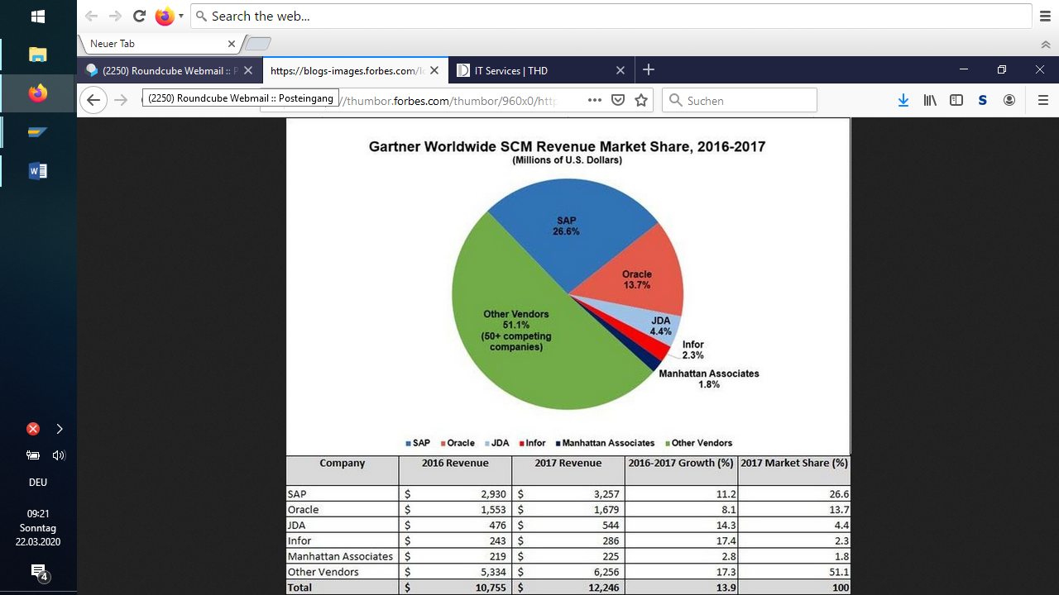

According to research firm Gartner, **SAP** had a **market share** of 22% of **global** ERP **market**, cloud and on-premises, while Oracle had an 11% **market share** in 2018.

SAP has more than 51,000 employees worldwide (as of July 2008), including approximately 10,600 employees in software development, and generated revenues of €10.3 billion in 2007[.](http://de.wikipedia.org/wiki/SAP#cite_note-8)

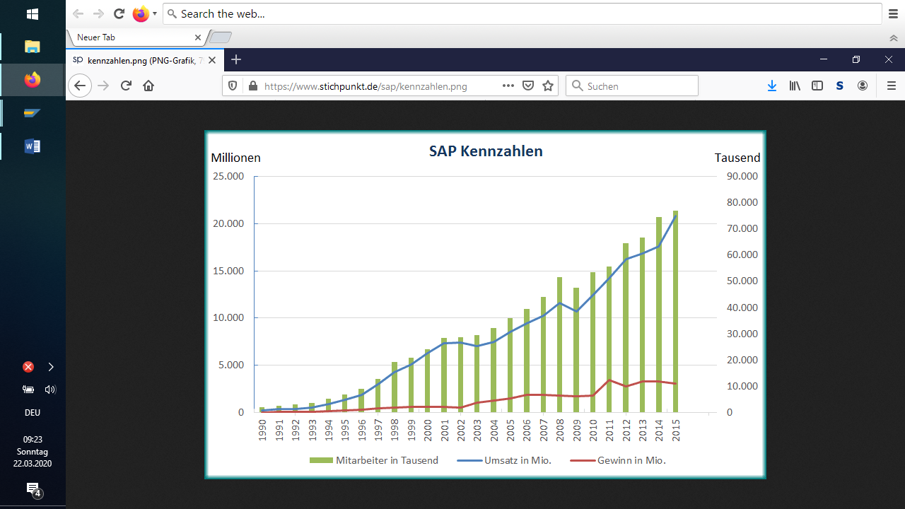

2019:

Employees 100330

Turnover 27.6 billion €

(Wikipedia)

Today, SAP has over 300,000 [customers](http://de.wikipedia.org/wiki/Kunde).

A few years ago there was only one monolithic [ERP software from the](http://de.wikipedia.org/wiki/Enterprise_Resource_Planning) manufacturer: [SAP R/3, which was](http://de.wikipedia.org/wiki/SAP_R/3) largely redeveloped in 1992 from the [mainframe-oriented](http://de.wikipedia.org/wiki/Gro%C3%9Frechner) predecessor [SAP R/2.](http://de.wikipedia.org/wiki/SAP_R/2) It consists of [modules that are](http://de.wikipedia.org/wiki/Modul_(Software)) functional but not [architecturally](http://de.wikipedia.org/wiki/Softwarearchitektur) separate. These are essentially: FI (Finance), CO (Controlling), MM (Materials Management), SD (Sales and Distribution), PP (Production Planning) and HR (Human Resources). These modules continue to form the core of the functionality used by SAP users.

It is now complemented by a range of other products that are now collectively called [SAP Business Suite](http://de.wikipedia.org/w/index.php?title=SAP_Business_Suite&action=edit&redlink=1). The [acronyms](http://de.wikipedia.org/wiki/Akronym) ERP, CRM, SCM, SRM etc. and the concepts behind them have not been developed by SAP and are also used by other IT providers. However, SAP uses the abbreviations to describe its software packages:

[Enterprise Resource Planning](http://de.wikipedia.org/wiki/Enterprise_Resource_Planning) (SAP ERP) is the former R/3, which last appeared independently in version 4.7, partly also called ERP Central Component. For further details on technology, architecture, function modules and user interface, see main article [SAP ERP](http://de.wikipedia.org/wiki/SAP_ERP).

[Customer Relationship Management](http://de.wikipedia.org/wiki/Customer-Relationship-Management) (SAP CRM) is an independent package that offers enhanced functionality for customer support using a standalone software architecture and runs on a separate server; common data, if any, is compared with the ERP via [replication.](http://de.wikipedia.org/wiki/Replizierung)

[Supply chain management](http://de.wikipedia.org/wiki/Supply-Chain-Management) (SAP SCM), [supplier relationship management](http://de.wikipedia.org/wiki/Supplier_Relationship_Management) (SAP SRM) and [product lifecycle management](http://de.wikipedia.org/wiki/Product_Lifecycle_Management) (SAP PLM) systems similarly complement the basic system with functions that can be used across industries.

Industry (IS - Industry Solutions) also offer specific enhancements to the normal functional scope of the R/3/ERP kernel. These include, for example, [SAP for Banking for](http://de.wikipedia.org/wiki/Loans_Management#SAP_Bankenplattform) banks and other companies that want to conduct banking business, [SAP for Retail for](http://de.wikipedia.org/wiki/SAP_for_Retail) retail, IS-Mill for the paper, textile, and steel industries, SAP for Healthcare (formerly IS-H) for hospitals (patient management and billing; SAP for Media for the media industry; IS-Oil for the oil industry; and [SAP for Utilities for](http://de.wikipedia.org/wiki/SAP_for_Utilities) the water, power, and gas industries).

***medium-sized solutions***

With SAP Business One, SAP Business All-in-One, and the SAP Business ByDesign product announced on September 19, 2007, previously known as A1S, the company now offers software that covers ERP functions for small, medium, and large enterprises.

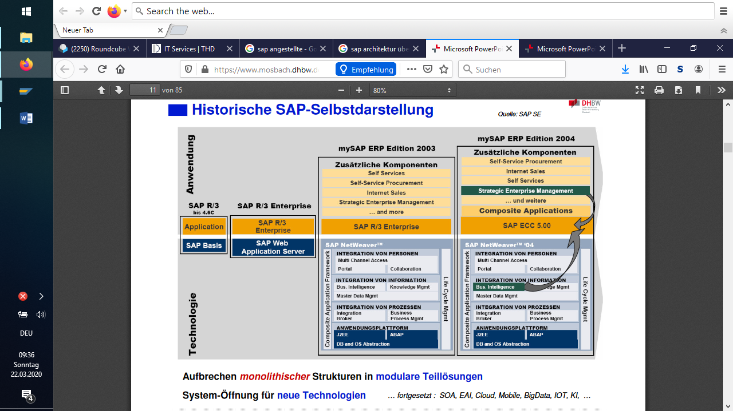

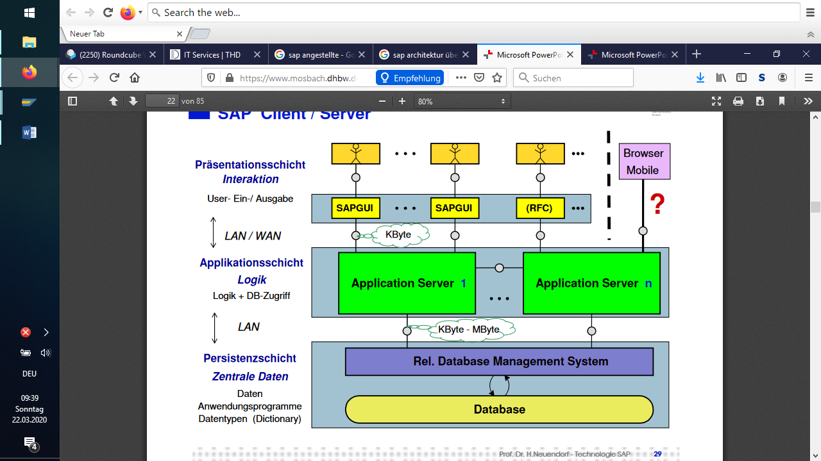

SAP NetWeaver comprises the following ***key areas***:

* Key areas of [people integration](http://help.sap.com/saphelp_nw70/helpdata/de/0f/25fc3f8fc2c542e10000000a1550b0/content.htm):
* multi-channel access
* portal
* collaboration
* Key Areas of [Information Integration](http://help.sap.com/saphelp_nw70/helpdata/de/0c/58497f411a7848985ae2aa0dda0bd3/content.htm):
* business intelligence
* BI content
* knowledge management
* master data management
* Key areas of [Process Integration](http://help.sap.com/saphelp_nw70/helpdata/de/20/68a72acfb61f4a9dfefa1901e8c3b6/content.htm):
* Integration Broker
* Business Process Management
* Key areas of the [Application Platform](http://help.sap.com/saphelp_nw70/helpdata/de/17/f1b640c9aa054fa12493e48912909c/content.htm):
* Cross-platform services
* ABAP engine
* virtual machine controller
* Java engine
* Business Services
* Key areas of [Solution Life Cycle Management](http://help.sap.com/saphelp_nw70/helpdata/de/6e/73863f06593a17e10000000a114084/content.htm):
  1. licensing
  2. solution monitoring
  3. statistics
  4. application log
  5. System Management
  6. Software Change Management
  7. SAP Solution Manager
  8. SAP NetWeaver Administrator
  9. customizing

SAP S/4 HANA

With InMemory database

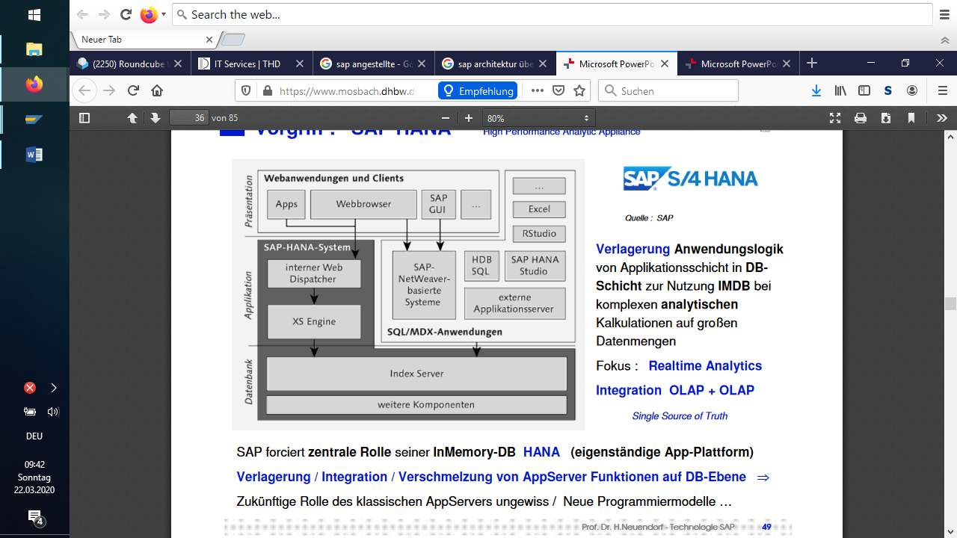

SAP Cloud platform

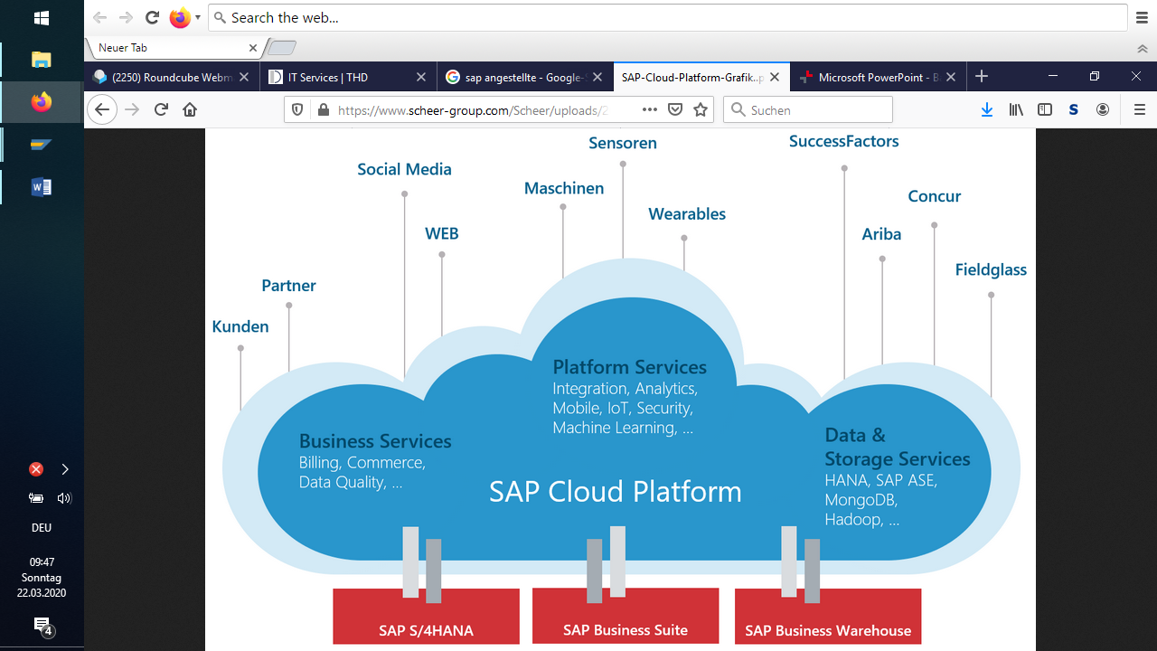

## Basic concepts

|  |  |
| --- | --- |
| business scenario | Business management meaningful summary of business transactions, e.g. personnel administration, balance sheet preparation, production, purchasing |
| organizational unit | Organizational grouping of enterprise areas that are grouped together for legal or business-specific reasons, such as corporate group, company, profit center. In SAP, the terms client, company code, plant, purchasing organization, and so on are used. |
| master data | Data that is used in the system for several business processes in the long term. This includes customers, materials, suppliers, etc. |
| transactions | Application programs that execute business activities in the system (such as creating sales orders, posting goods receipts, and so on). |
| voucher | Data record that is generated by the execution of a transcription. |
| reports | Program that reads certain datasets and formats them in the form of a list. |

## Organization

### All organization levels

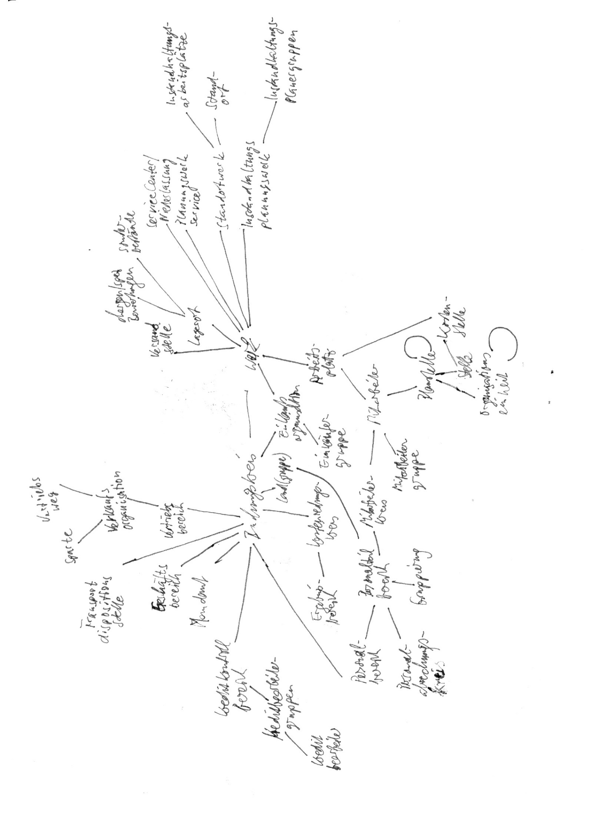

The structure of an enterprise is mapped to the enterprise via the organizational units. The use of organizational units in SAP is so flexible that all possible structures can be mapped. (For example, one sales organization per subsidiary in a corporate group or a general sales organization, and so on).

### Organization in Materials Management



And that corresponds to

|  |  |
| --- | --- |
| Client | a group |
| company code | a company or subsidiary that is a reporting entity |
| plant | a production facility with its own logistics and production facilities |
| purchasing organization | Department for ordering that is responsible for one or more plants or company codes. Each purchasing organization usually makes its own agreements with the vendors. |
| storage locations | Different storage areas with their own inventory management, that is, the stock transfer from one storage location to another is posted as goods issue and goods receipt. |

### Organization in Sales



### Organization in production



### Organization in Financial Accounting



## Master data

Master data in SAP usually has different views so that different organizational units can access the same data and thus avoid redundancy.

### Customer master contains the following views:

|  |  |
| --- | --- |
| General data | apply at client level, i.e. across companies, and include name and address, among other things |
| Company code-specific data | are valid for each company code, which means that different data can be maintained for a customer in different company codes. This data contains accounting-relevant data, such as terms of payment and assignment to accounts in accounting. This data is usually maintained by Accounting. |
| Sales-specific data | are valid for each distribution channel and are maintained by Sales; contain data such as shipping conditions and pricing data. |

### Vendor master

Vendor master data is structured in the same way as customer master data:

General data

Company code-specific data

Purchasing Organization-Specific Data

### Material master

Material master contains the following views:

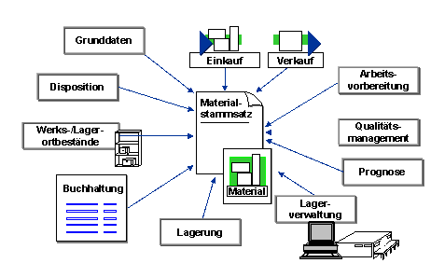

The material master is the central source in an enterprise for material-specific data. It is used by all components of the SAP logistics system.

The access of the different organizational units to the same master data eliminates redundancy. The material data is required for the following functions, for example:

* In Purchasing for order processing
* In Inventory Management for the entry of goods movements and physical inventory
* in sales and distribution for order processing
* In invoice verification for posting invoices
* in production planning and control for demand planning, scheduling and production planning

# Working with SAP

## SAP via VPN

You can work with SAP from everywhere. You need only web access and then you can use the SAP system of the THD via VPN.

Link für SAP-Infos:  
<https://intranet.th-deg.de/aww/sap>

### Install VPN

Download from

https://www.th-deg.de/de/studierende/it-services#itdienste

### Install SAP GUI:

<https://intranet.th-deg.de/aww/sap>

#### Download GUI 7.50

#### Unzip the download file

#### Run the setup exe

You find it at:

sapgui750c2p1\BD\_NW\_7.0\_Presentation\_7.50\_Comp.\_2\_\PRES1\GUI\WINDOWS\Win32\SapGuiSetup.exe

### Store the [SAPUILandscape.xml](http://www.bw.fh-deggendorf.de/sap/SAPUILandscape.xml)

from

<https://intranet.th-deg.de/aww/sap>

in a folder you can reach from each computer (for example in I:).

### Run VPN

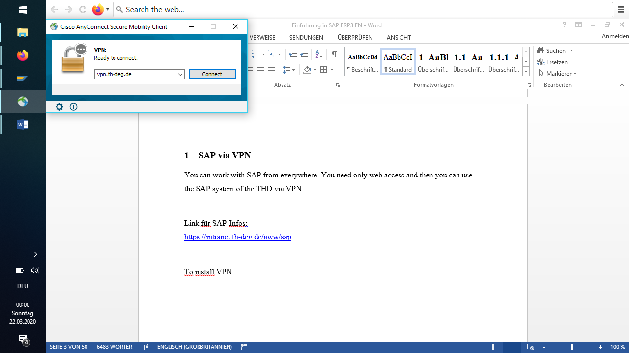

### Assign the SAPUILandscape.xml

Assign the SAPUILandscape.xml in SAP GUI (only possible if you have connection via VPN):

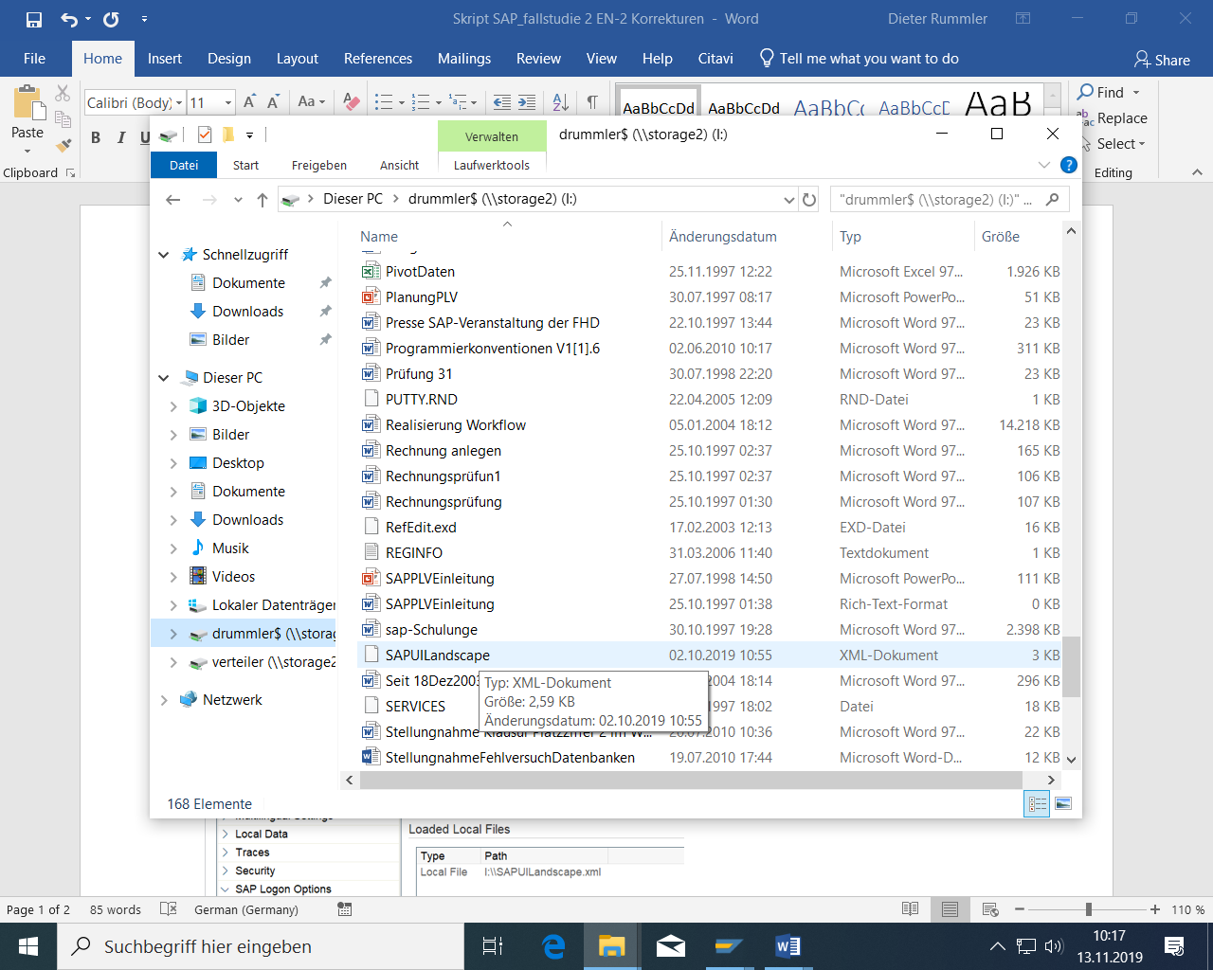

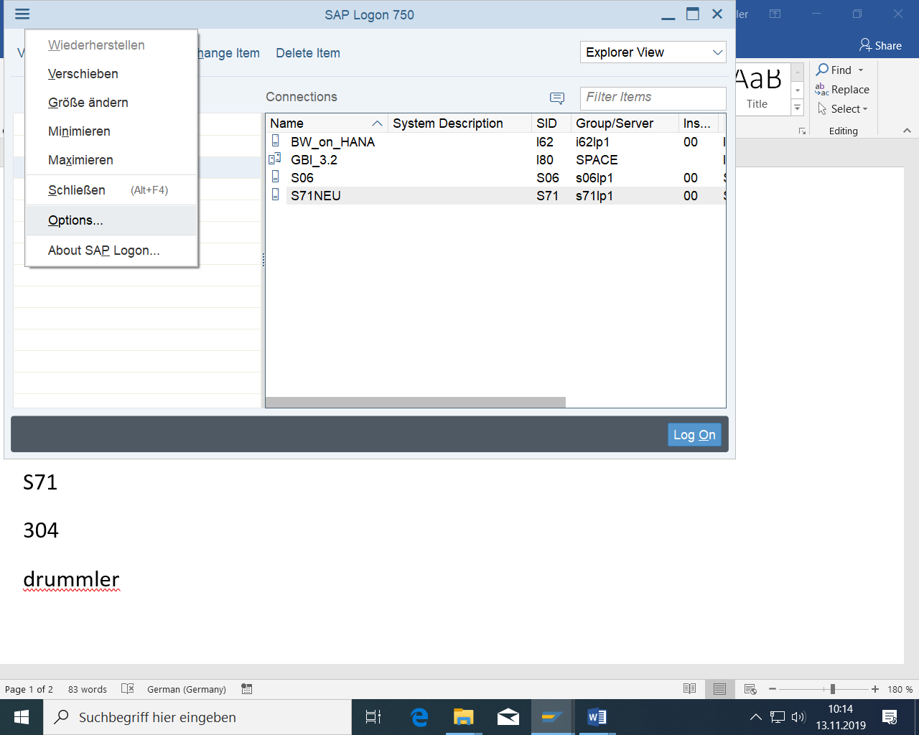

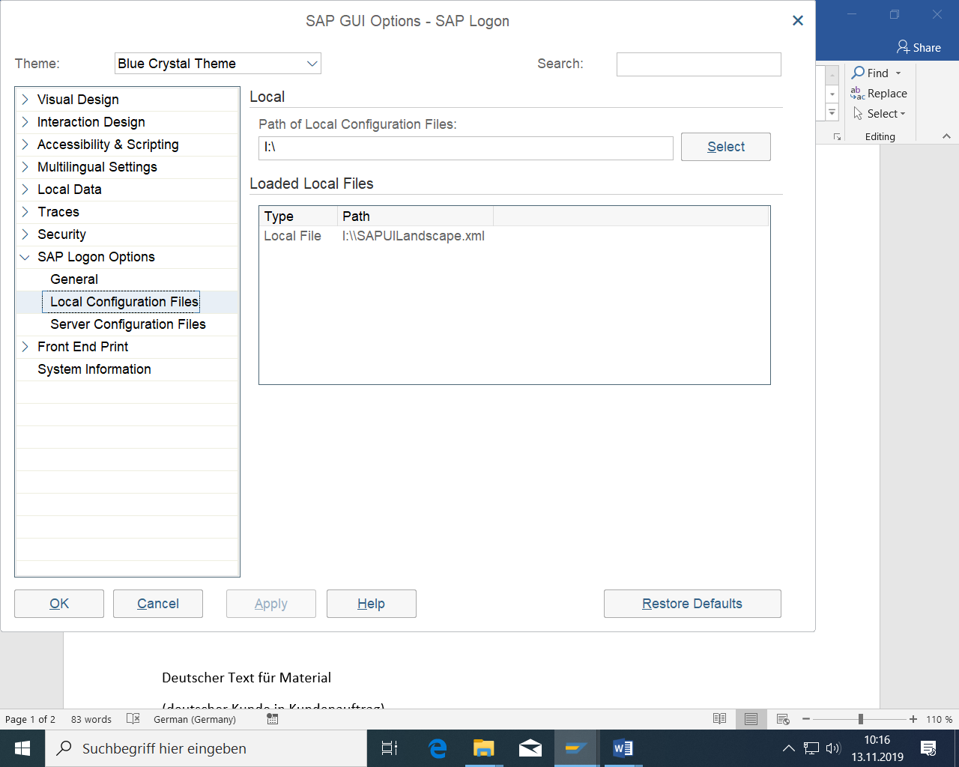

Then: Apply

### Logins

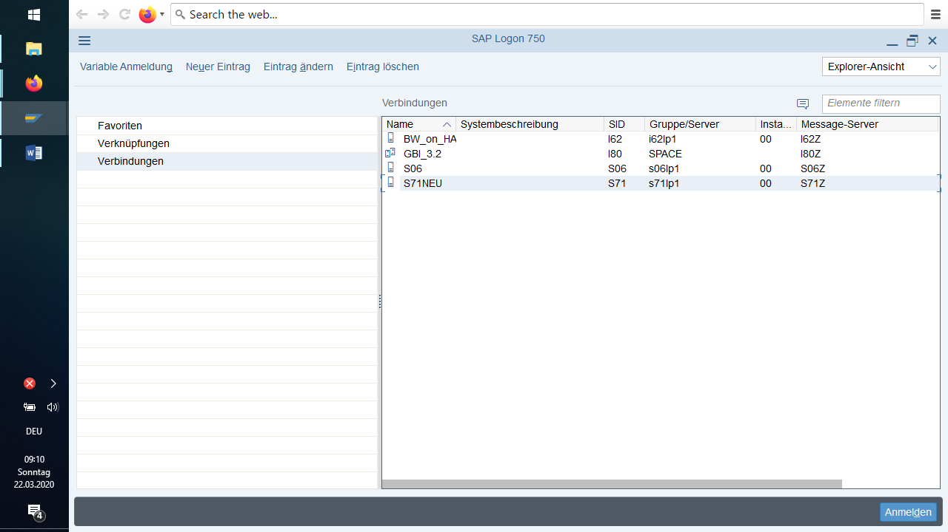

S71NEU

Client 304

User ss20dr-000 - ss20dr-060  
Password sapss20

Language EN  
  
  
S06  
User ss20dr-000 - ss20dr-030  
Password  sapss20

At the first login the password has to be changed.

## Login to the system

For the first registration, you will receive a user name and password, as well as the client in which the business event takes place. The default password has to be changed the first time you log in.

In SAP, a client corresponds to a closed group of companies.

Open the login window via the button "SAPLogon" or via Start > Programs.

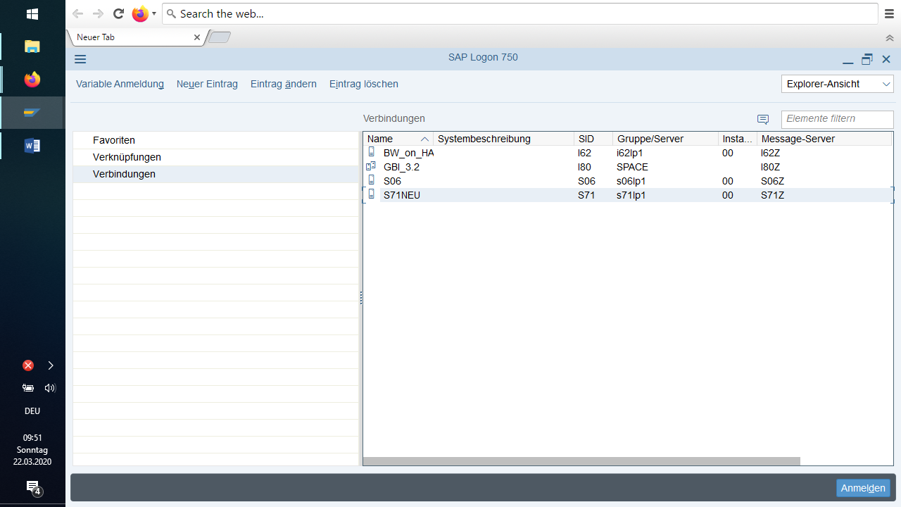

You will receive the login window. Various systems are already available for selection there.

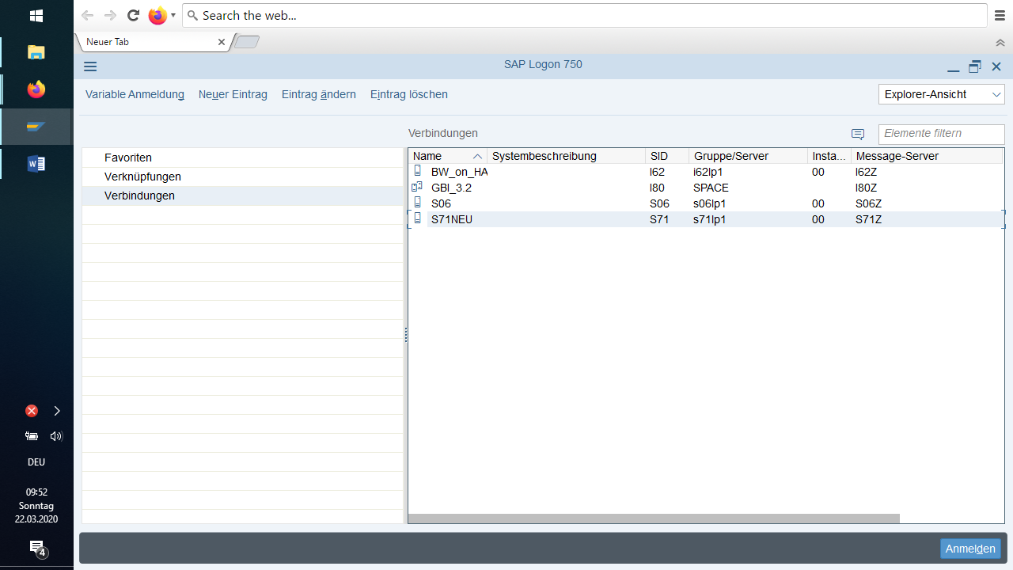

To see which systems are involved, select an entry and press the Properties button.

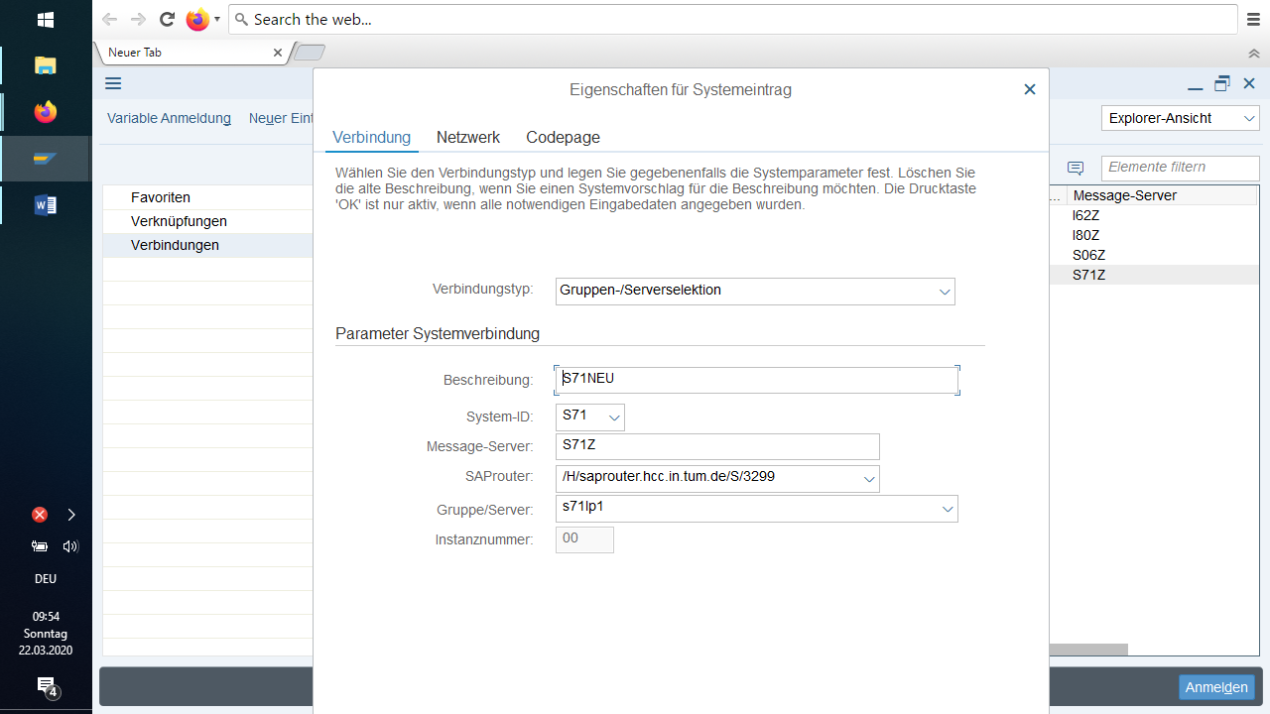

Click on the "Logon" button or double-click on a system to open the login screen:

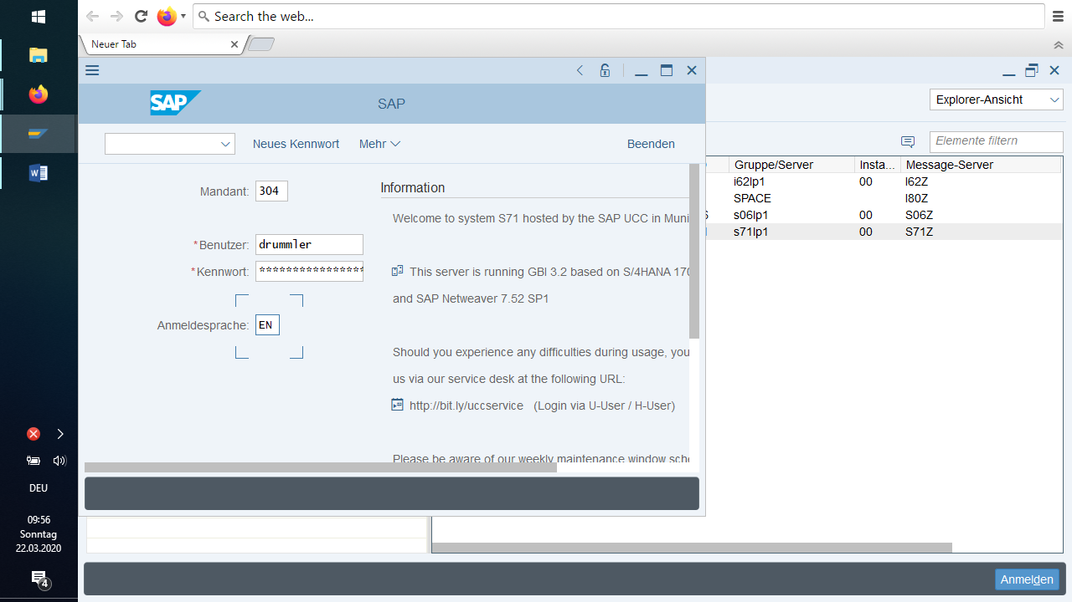

TIP: You can move through the input fields of the SAP System using the TAB key. Depending on the setting, the cursor automatically jumps to the next field when all characters of a field have been entered.

Enter blank: you get the last entry

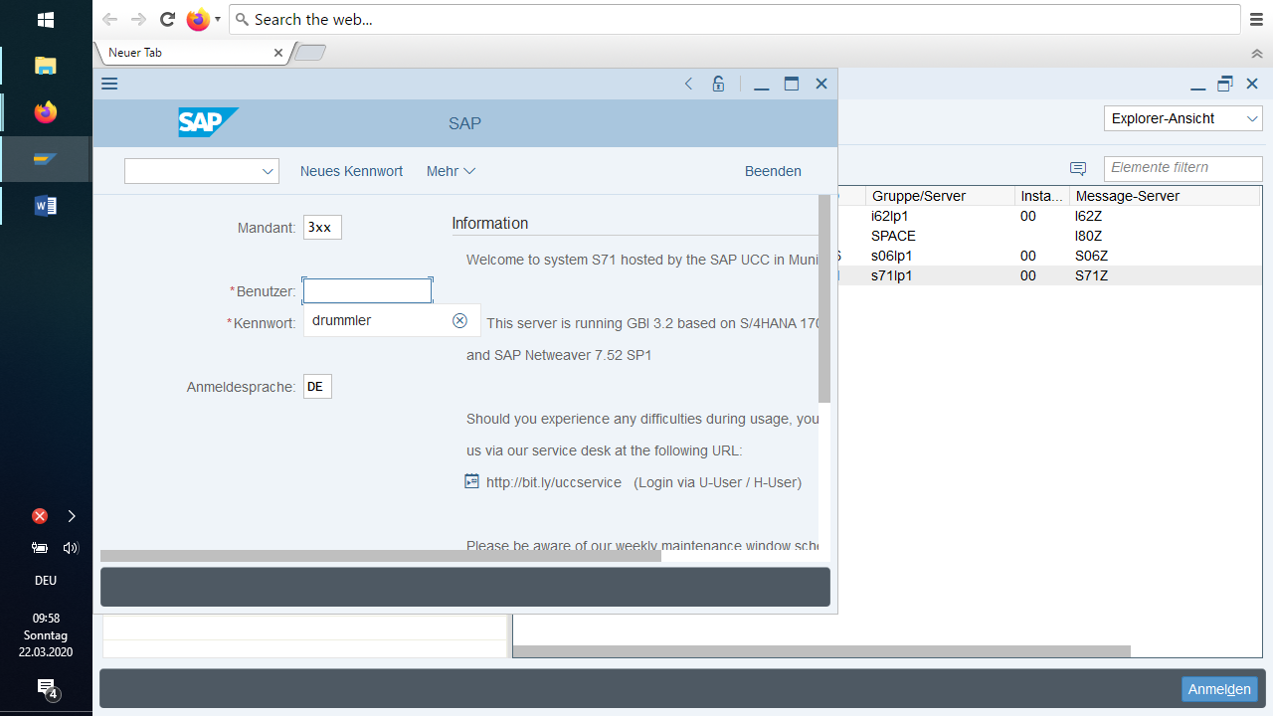

Enter the client specified by the instructor in the Client field. In User, the user name assigned to you and then your password. Under Language, you can select the language in which the SAP screen templates are displayed. Here no input is necessary, since the systems are preset in German.

When you log in for the first time, you must change your password.

The initial screen of the standard SAP System appears as the result of the logon.

## Change password

To create a valid password:

* Enter a minimum of three and a maximum of eight characters.
  + Use alphanumeric characters. Valid characters are
  + all letters from A to Z
  + all numbers from 0 to 9
  + punctuation marks
* Do not start the password with the following characters:
  + a question mark (?)
  + an exclamation mark (!)
  + a space
* Do not start with three identical characters (like bbbat).
* Do not start the password with three consecutive characters that are also contained in your username (if your username is Mouse, you cannot use it as a password).
* Do not choose pass or init as the password.
* Do not use any of your last five passwords (this does not apply the first time you log on to the system).
* When entering your password, you do not have to pay attention to upper and lower case. If you use e.g. blue as password**,** the system accepts both blue and BLUE.

You only change the password in the initial screen. Enter your mandate, user and password and select "New password".



## Log out

You can log off from any screen in the SAP System.

You have the following options:

* In the menu bar, choose *More* *System Log Off.*
* Click the "x" icon in the top right corner of the title bar (if you have only one mode open).
* *The Logoff* dialog box appears, informing you that unsaved data is lost when you logoff.

If you are not sure whether you have saved all your data and do not want to log off, choose *No*. You return to the last screen you edited.

If you are sure that you have saved all your data, choose *Yes*. All windows of the SAP System are closed and you have successfully logged off from the SAP System.

If you have several sessions open, the system does not log you out until you close the last session. Note: When closing a mode, there is no indication that unsaved data will be lost while a mode is still open.

## Close GUI Window

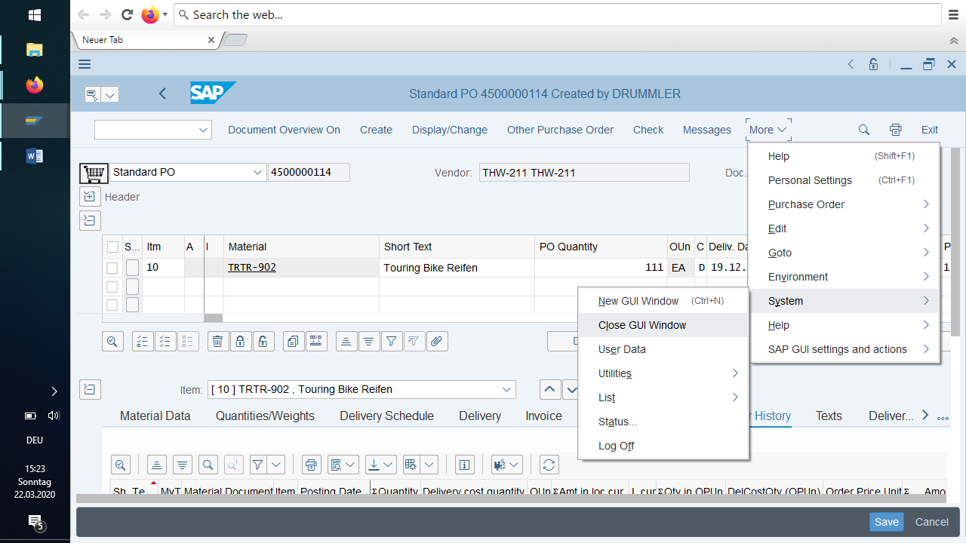

## Settings

To make system settings for **SAP Easy Access, choose** *More Extras Settings*.

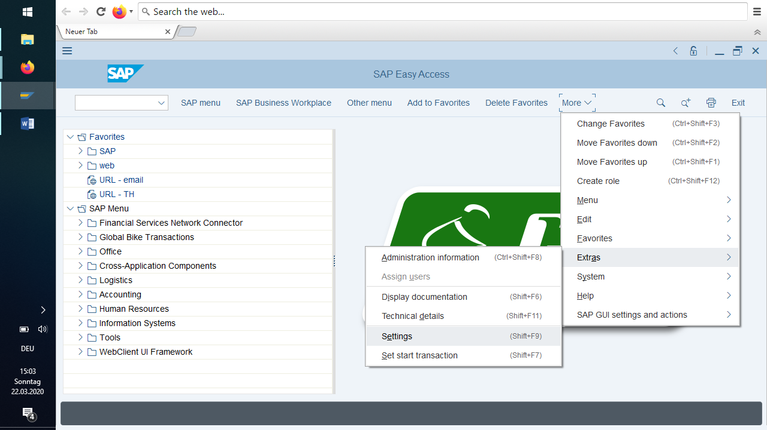

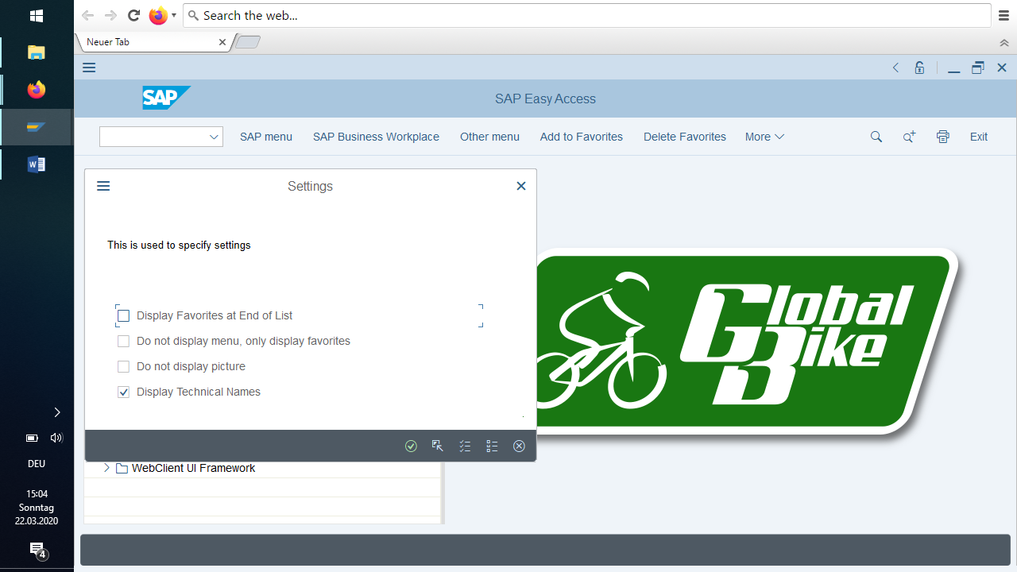

Here you can determine whether

* the favorites should appear before or after the menu
* a menu is to be displayed in addition to the favorites at all
* The technical names of the menu entries are to appear in the work center menu; technical names here refer to the transaction codes of the individual screens, which can also be used for direct selection of the screens:

Without this setting:

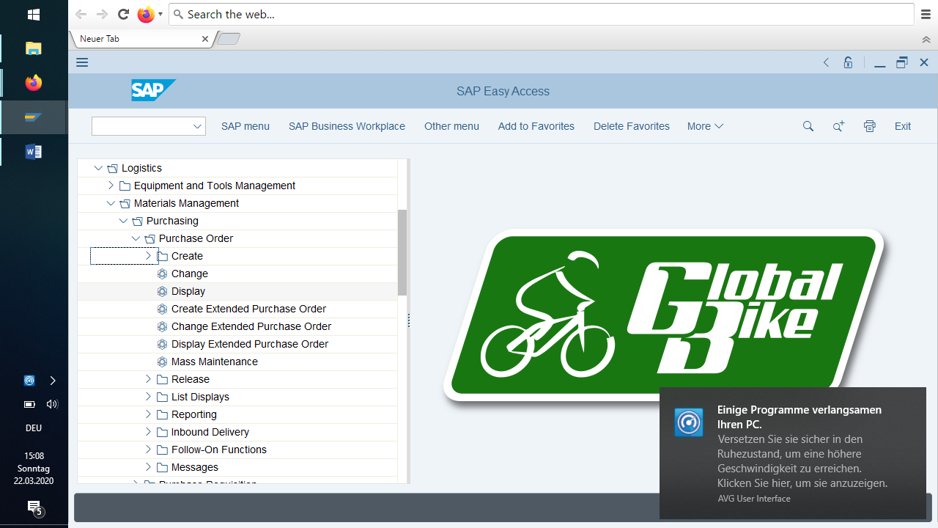

With this setting:

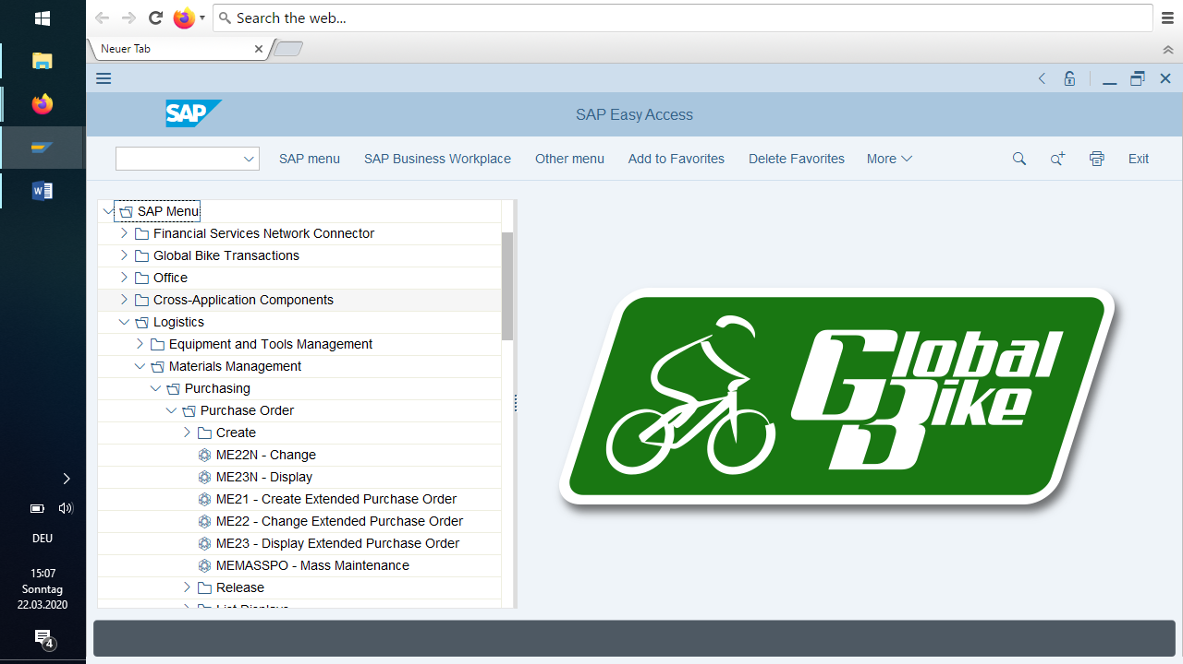

You can now see the transaction codes (for example ME22N)

## New GUI Window, Stop transaction

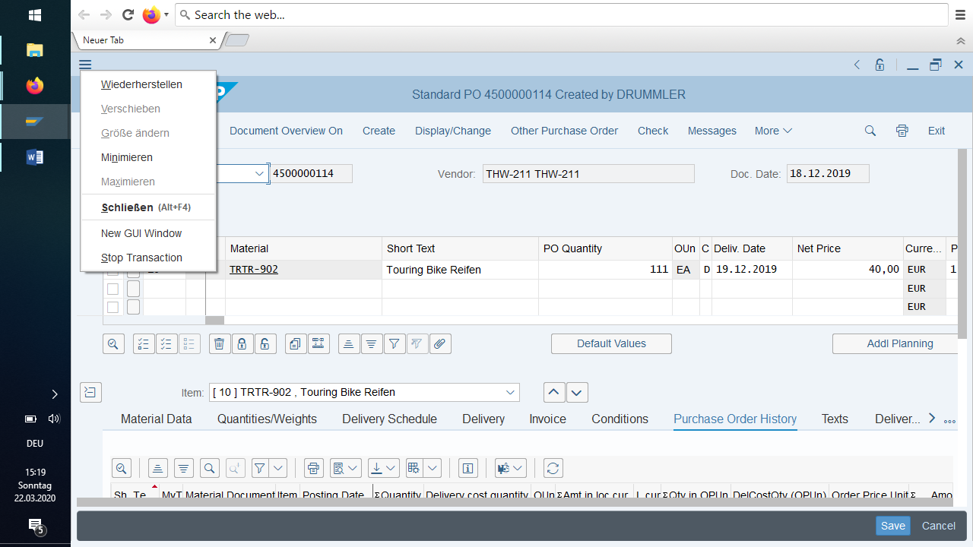

After New GUI Window:

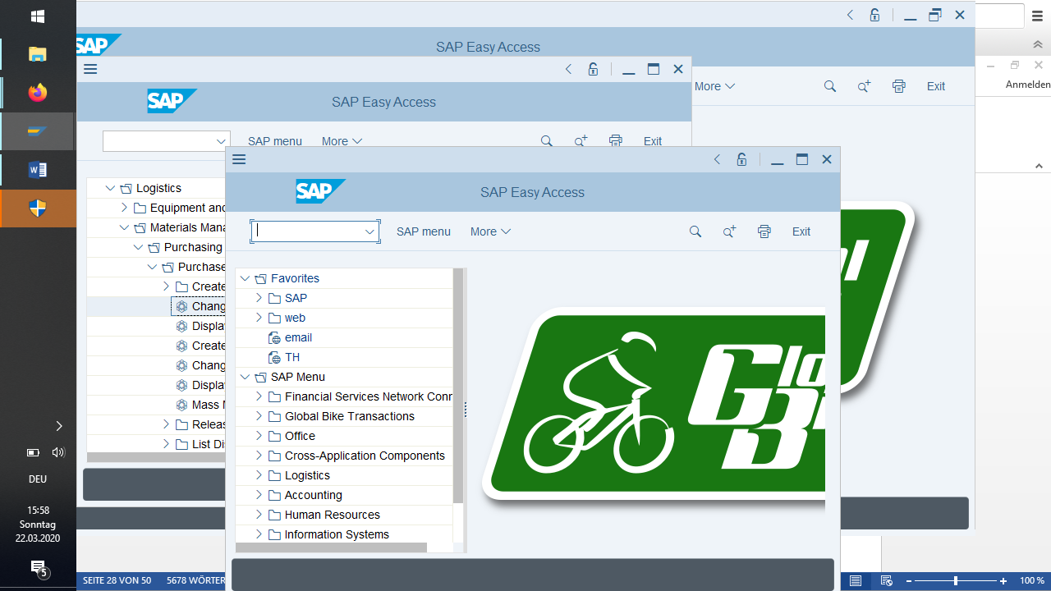

## The system information

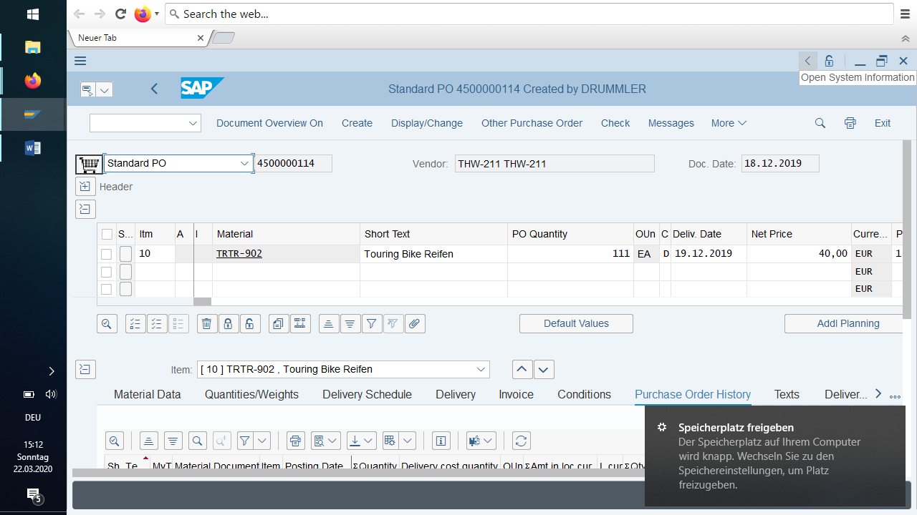

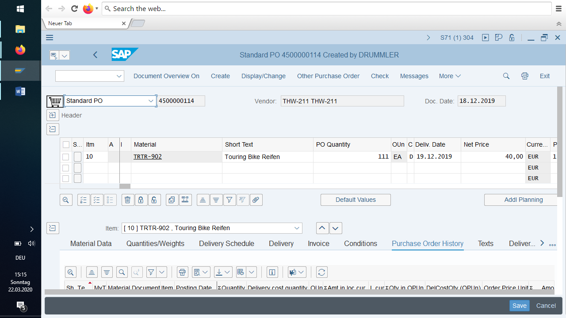

## Go forward

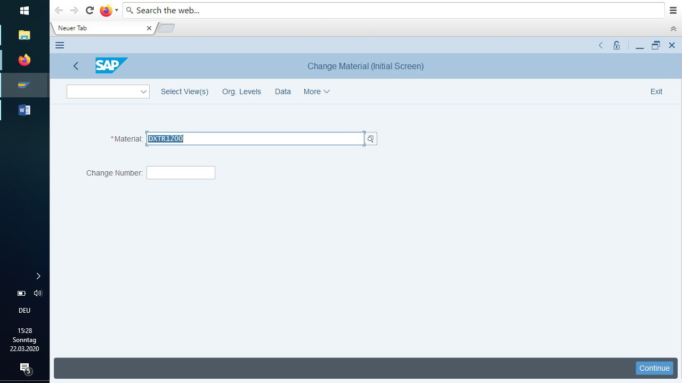

Continue

Sometimes it works with

Enter

## Status

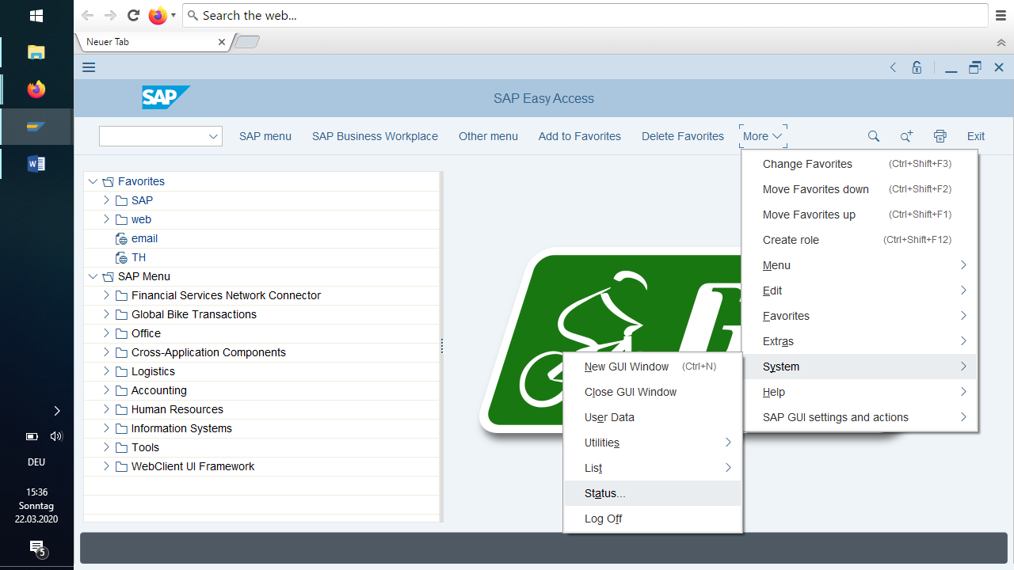

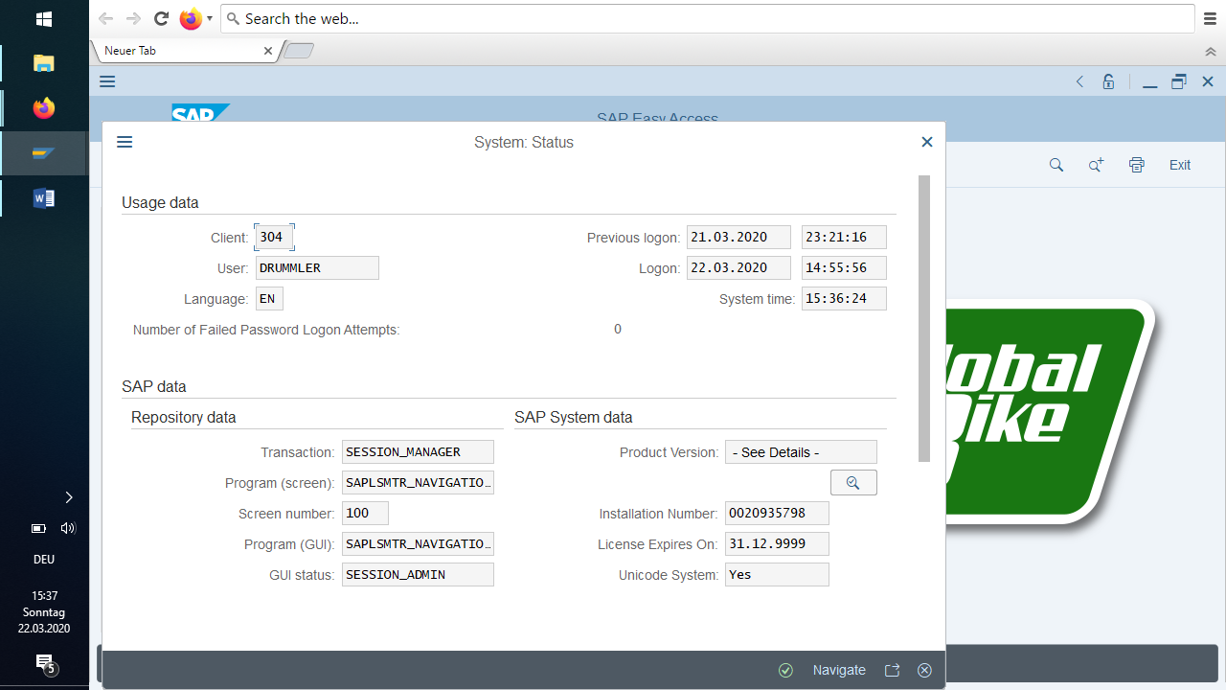

## System messages

System messages are displayed on the far left after actions.

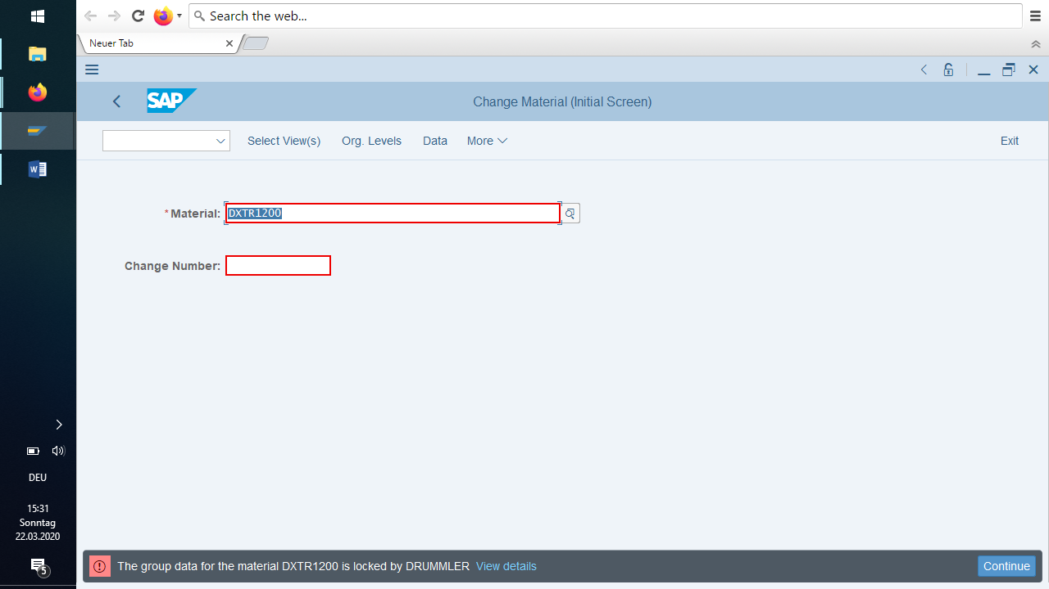

View Details:

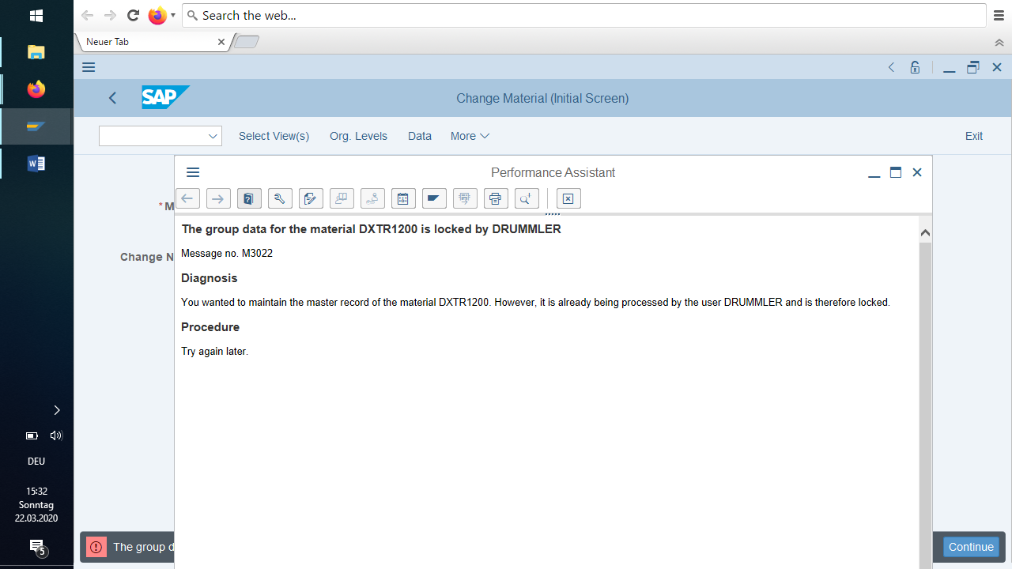

## The menu bar

The menu bar is located below the title bar of an SAP screen. You can use the menu bar to access a particular transaction without having to know the corresponding code. The menus displayed will vary depending on the application you are editing.

The following screenshot shows a typical SAP menu bar.

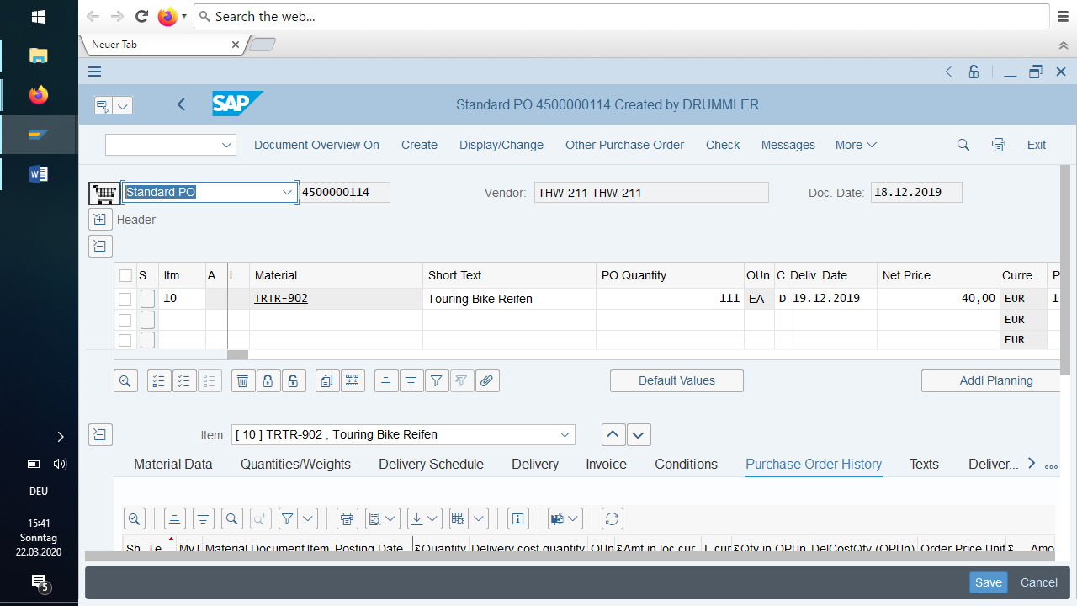

## Navigation

After you have logged on to the SAP System, select the application you want to work with. You can switch to an application other than the selected one at any time.

There are two ways of calling an application in the SAP System:

You can select an application from the **SAP  
 Easy Access work center menu.** You can use this menu to easily find your application without the need to remember the transaction code.

This is the better way, because you can find the transaction also later (even you forgot the transaction code already):

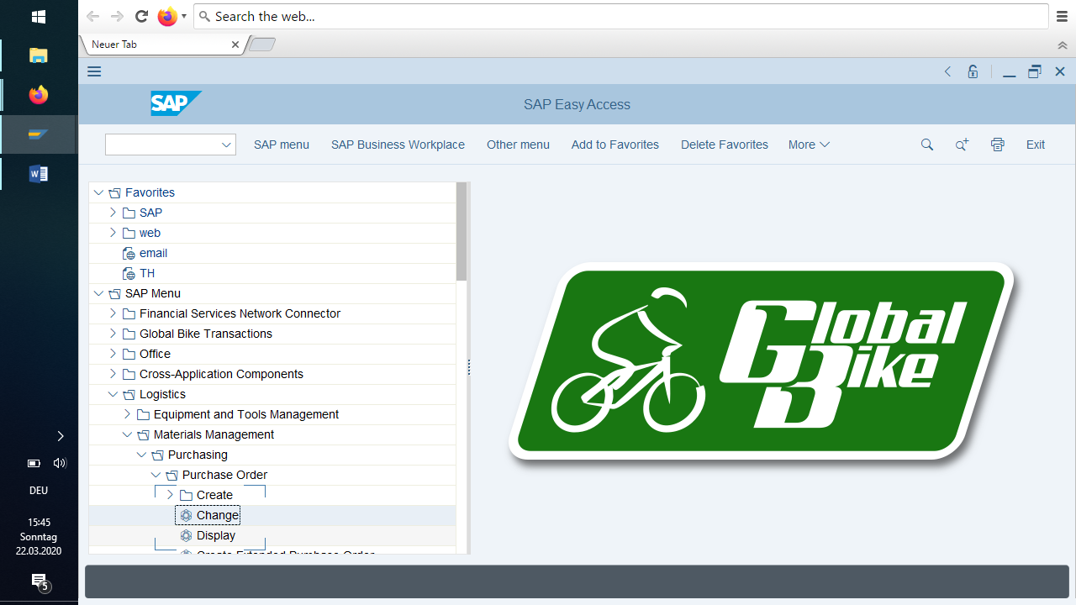

You can enter a **transaction code** in the command field. Transaction codes enable you to access an application directly without having to navigate through the various menus of the system hierarchy.

## Transaction codes

### What are transaction codes

There is a transaction code for each application in the SAP System. A code can consist of letters, numbers or both. Example: *FB05* or *SUSR*. Enter transaction codes in the command field.

Instead of selecting an application from the work center menu, you can call up an application by entering a transaction code in one step and trigger the corresponding function. Although this form of navigation requires you to remember certain codes, you will achieve the desired function much more quickly.

By entering a transaction code, you go directly to the initial screen of an application ("transaction"). If, for example, you work in the *Financial Accounting Accounts Receivable* application area and want to create a customer master record, you can select the corresponding menu entry or enter the corresponding transaction code in the command field, in this case *FD01*.

You can use transaction codes to call applications in other application areas from your application area. If, for example, you work in the *Financial Accounting Accounts Receivable* application area, you can switch to the *Financial Accounting Accounts Payable* application area and edit an application there.

Prerequisite: You know the transaction codes that are important for you.

### Search transaction codes

To call an application using a transaction code, you must know the corresponding transaction code.

To determine the transaction code for a particular application, position the cursor on the desired function (that is, the menu entry) in the SAP Easy Access work center menu. Then you have the following options:

Choose *More Extras Technical details*:

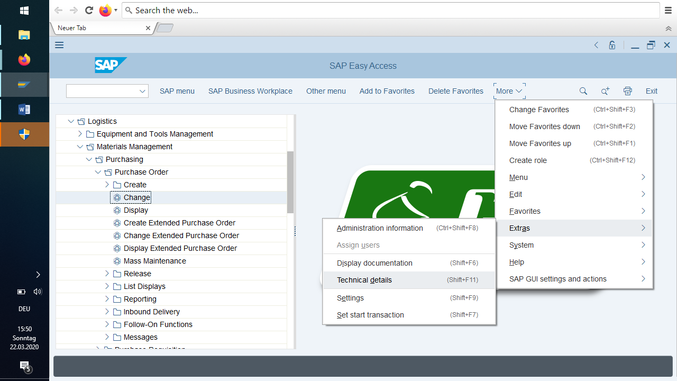  
A dialog box appears in which you see detailed information on the selected menu entry: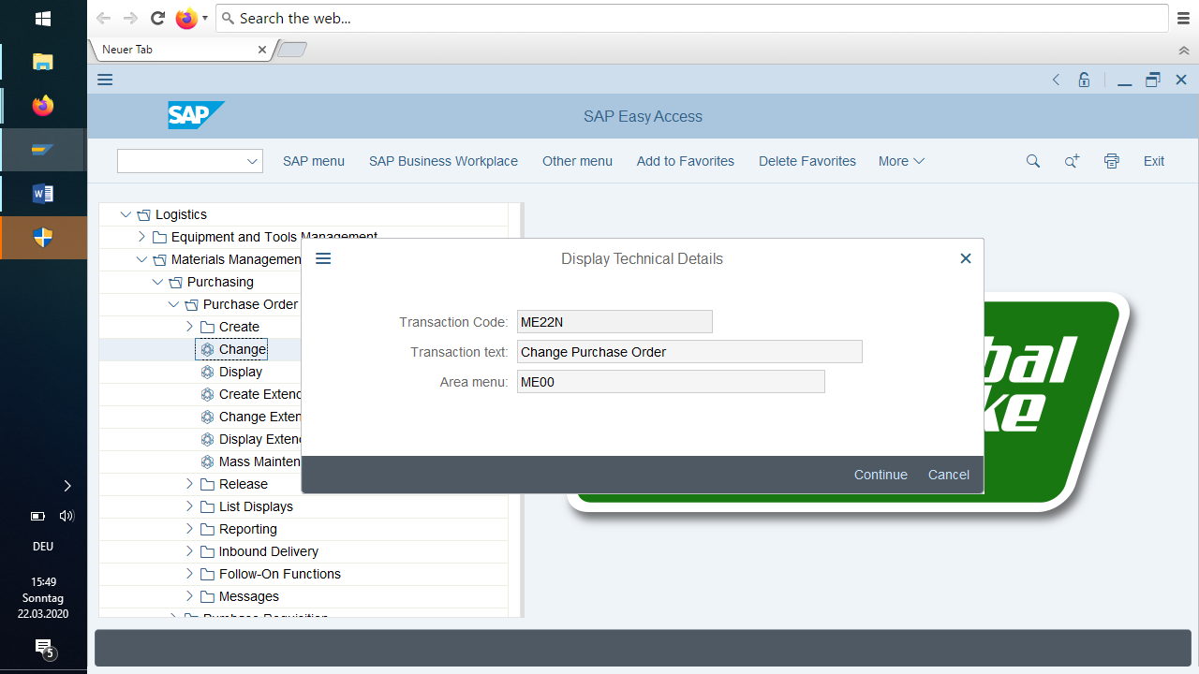

Alternatively, you can choose *More Extras Settings Display Technical Names.* The menu closes. When you reopen it, all menu options of the work center menu (not just the menu option you selected) are displayed with their transaction codes:

You can now start the application from the result screen by double-clicking the menu entry or choosing *Enter.* Otherwise, you can enter the transaction code determined on any screen in the SAP System. After entering a transaction code, the system terminates your current application and goes to the initial screen of the new application.

### Enter transaction codes

Place the cursor on the command field.

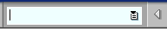 .   
To display a list of the most recently used transactions, choose the down arrow on the right side of the command field.

In the command field, type /n (to exit the current application) and the corresponding transaction code. For example, to access  
the initial screen of transaction *MB01,* you must enter the following: /nmb01.  
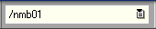

Choose *Enter*.   
You leave the application and go to the initial screen of the new application.   
If you do not want to stop editing, but want to edit objects in another application at the same time, you can open a new mode. For example, you create a purchase order and want to view the currency table. You can display the table in a different mode without having to finish processing the purchase order.

You can display a history of the transaction codes you have entered using the down arrow on the right-hand side of the input field.

Parallel working with multiple windows (modes)

If you want to work on more than one application in the SAP System, you can open additional windows or sessions. This saves you the hassle of jumping back and forth between the images of the corresponding applications.

You can create up to six different modes and edit a different or the same application in each. You can jump back and forth between open modes, and you can close a mode without having to log off the system.

### Exit transaction

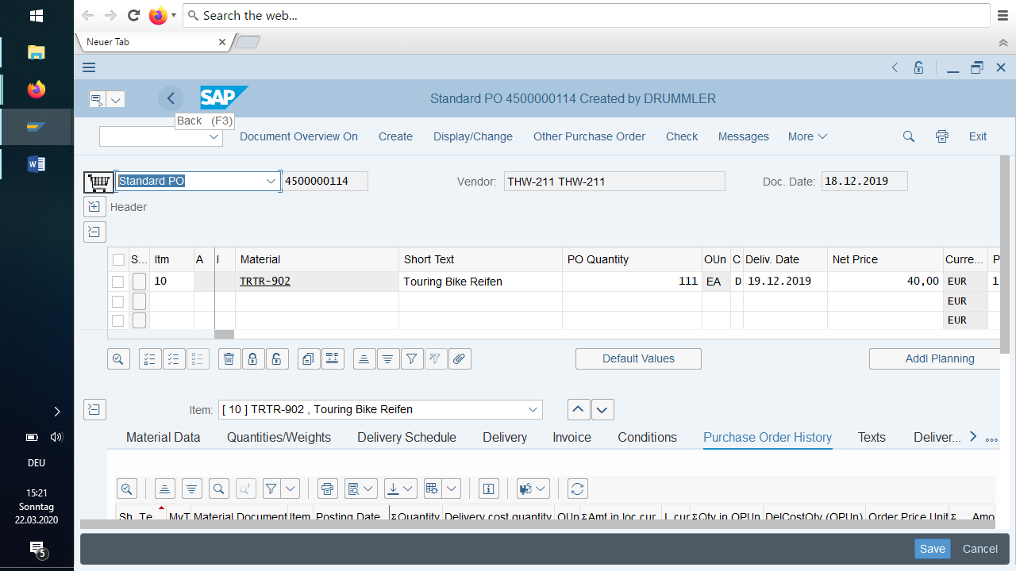

Or

with /n as transaction code.

## SAP GUI modes

In the SAP System, you can open a new session at any time and from any screen. No data will be lost in already opened modes. You can open up to six modes that work independently of each other. When you close one mode, the other open modes remain operational.

The system opens an additional window with the new mode. The new mode is the top window on your screen, i.e. the active window. The active window remains until you switch to another mode or create another one.

Each mode has a mode number that is displayed in the status bar. It appears in brackets next to the system name.

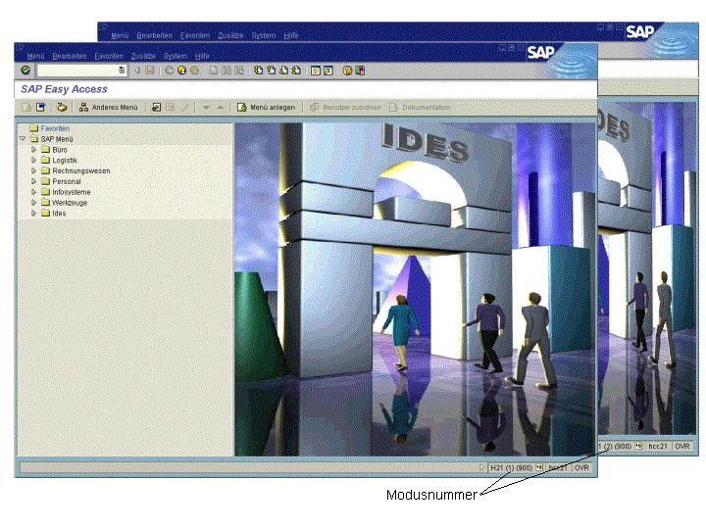

### Open mode and application simultaneously

In the SAP System, you can create a new session by entering a transaction code and start an application at the same time. If you have created a new session in this way, the system displays the initial screen of the application opened at the same time. However, you must know the transaction code of the corresponding application.

In the command field, type the command /o (slash and­ letter o) and the transaction code of the desired application. For example, to­ create­ a session and application with transaction code *FD01* (­Create customer master record in­ Accounts Receivable application area­), enter /ofd01 in the command field.

Choose *Enter*.

The system opens a new window for the new session and displays the initial screen of the selected application.

### Change modes

You can jump from one mode to another. If you switch to another mode, you will not lose any data. As long as you are logged on to the SAP System, you can leave a session for as long as you like and resume work there at any time.

Click anywhere in the window where the desired mode is located (or select the key combination provided).

The selected window becomes the active window, i.e. it overlays all other windows on your screen.

If you have several modes open, you can minimize the currently unused modes, i.e. turn them into icons. If you want to use one of the modes again later, you can make it active again by clicking on the corresponding icon in the status bar.

Minimizing unneeded modes significantly reduces memory usage.

#### Close mode

When you have finished working in a mode, you should exit the mode. Each open session consumes system resources and affects the response times of the SAP System. Before you close a session, save any data you want to keep. When you close the mode, the system **does NOT prompt you** to save your data.

If you have only one opened mode and close it, you log off from the system. In this case, however, the system prompts you to save your data before logging off.

## Favorites

In SAP Easy Access, you can create a favorites list that can include the following:

* transactions
* files
* web addresses

The easiest way to create a menu entry as a Favourite is via Drag&Drop. Proceed as follows:

Select an executable entry in the menu with the mouse and keep the mouse button pressed.

Drag the entry to the desired position in the Favorites list and release the mouse button.

The new entry appears below the point where you dropped it in the Favorites list.

Alternatively, you can create such an entry via the menu bar:

Select an executable entry in the user menu.

Choose *Add Favorites.*

The new entry is placed at the end of your Favorites list.

Alternatively right mouse click on Favourites

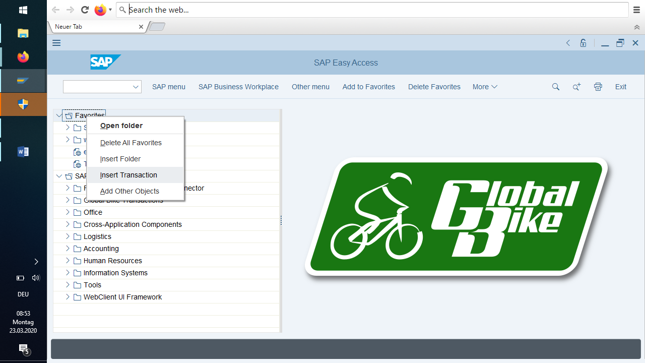

Adding a transaction to the favorites list

Choose *Insert Transaction.*

A dialog box appears. Enter the required transaction code and choose *Continue*.

The new entry is placed at the end of your Favorites list. The transaction name is assigned automatically.

Inserting a web address or a file

Select *Favorites Web Add Other Objects*

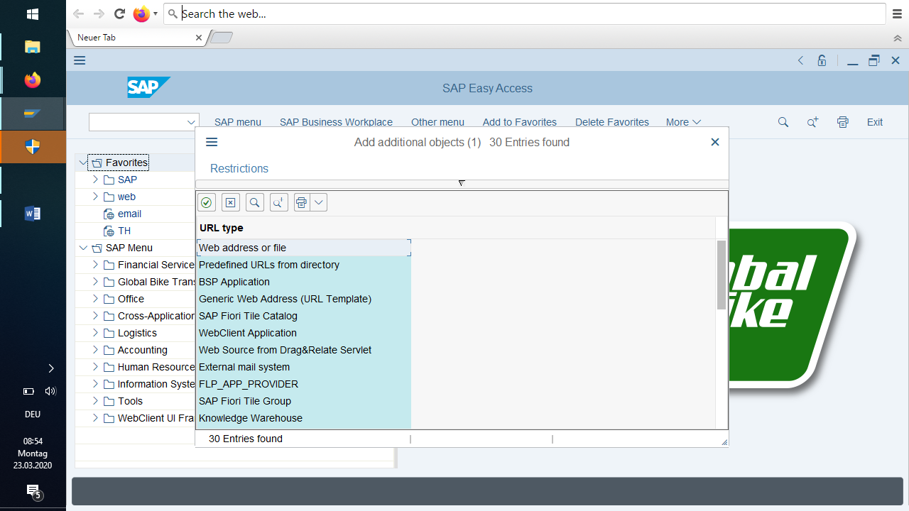*.*

A dialog box appears again. Enter a name for the favorite and the Web address or file name you want, and choose *Continue*.

The web address should conform to the naming convention *http://...* follow. A valid example would be *http://www.sap.com*

The file name should follow the convention *X:\File name\File path. A* valid example would be *C:\Texts\SAP.doc.* This functionality is only available if you can access local files from your Web browser.

The SAP Easy Access provides you with a number of functions for organizing and sorting favorites that have already been created hierarchically:

* You can add folders to the Favorites list.
* You can move, rename, or delete created favorites and folders.

## Working with Fields

When working with the SAP System, you must enter data in input fields.

The fields can be selected with the mouse and the keyboard.

The tab key moves from field to field. If a field is filled completely, the system automatically switches to the next field in the standard setting.

You can switch between insert and overwrite mode.

You can select field contents and copy them to the clipboard and paste them into another field.

There are mandatory and optional fields. Required fields are marked with a red star:

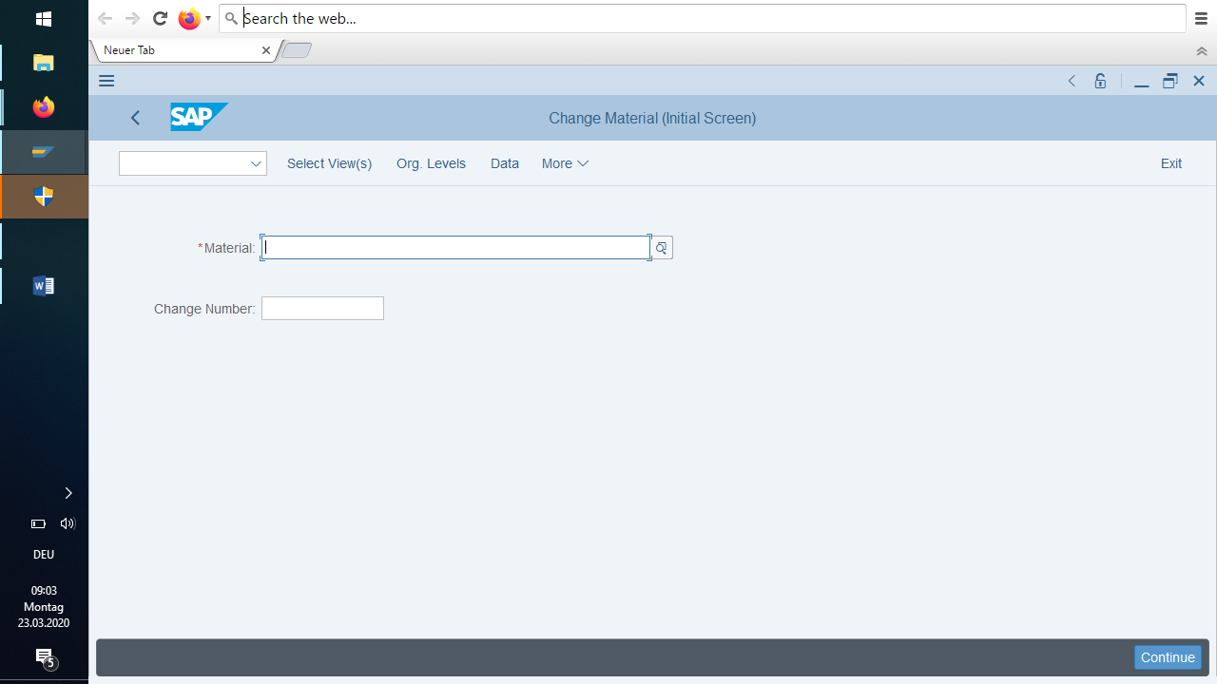

You cannot switch to the next screen until all required fields have been filled. However, there are also required fields that are not marked as such, for example, because they only became required fields the moment you entered data in another field.

If an application consists of several screens (for example, material master), the contents of one screen are only saved temporarily when the screen is changed. After all images have been filled, the data has to be finally saved.

When you leave a template, the system usually informs you that data has not yet been saved and prompts you to save it.

## Function keys

You can get an overview of the assigned function keys from the context menu that you access when you press the right mouse button in a free screen area:

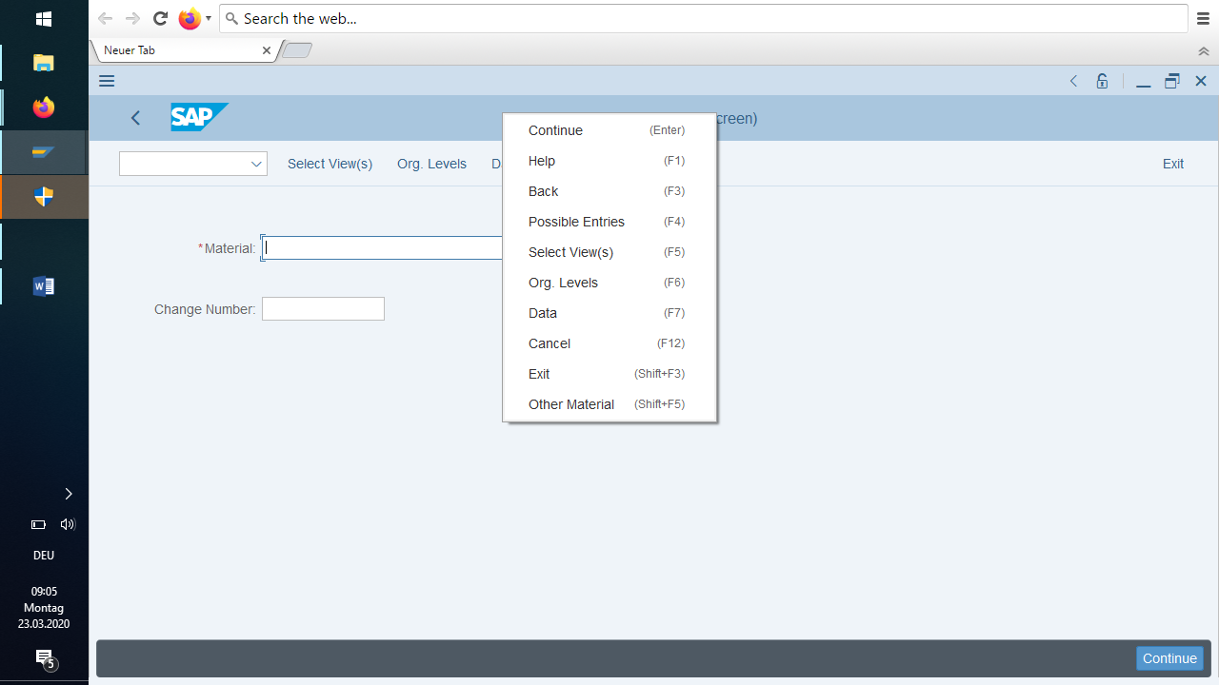

## User Data

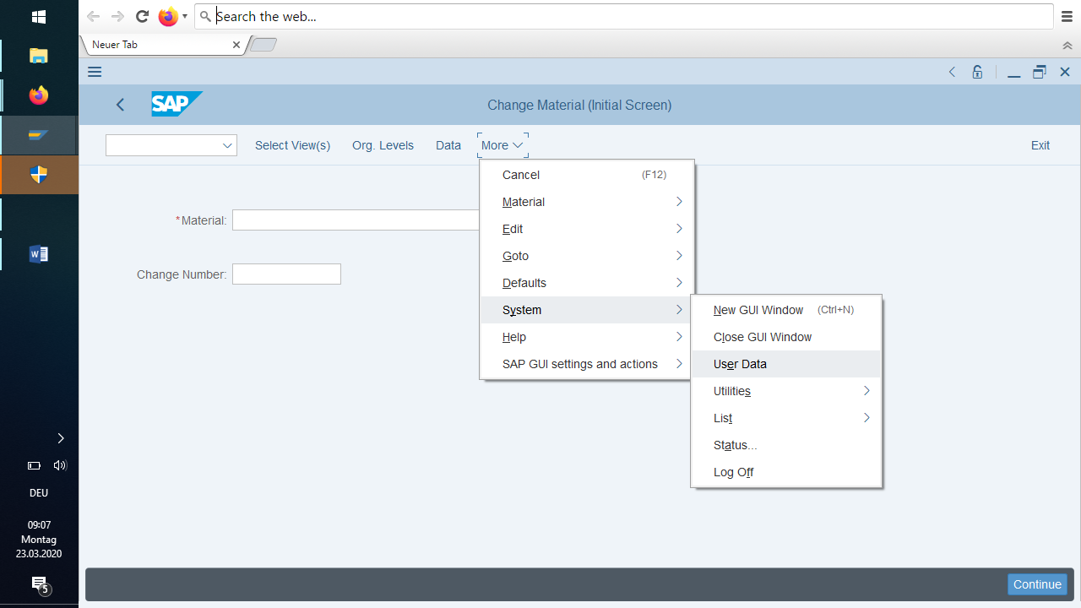

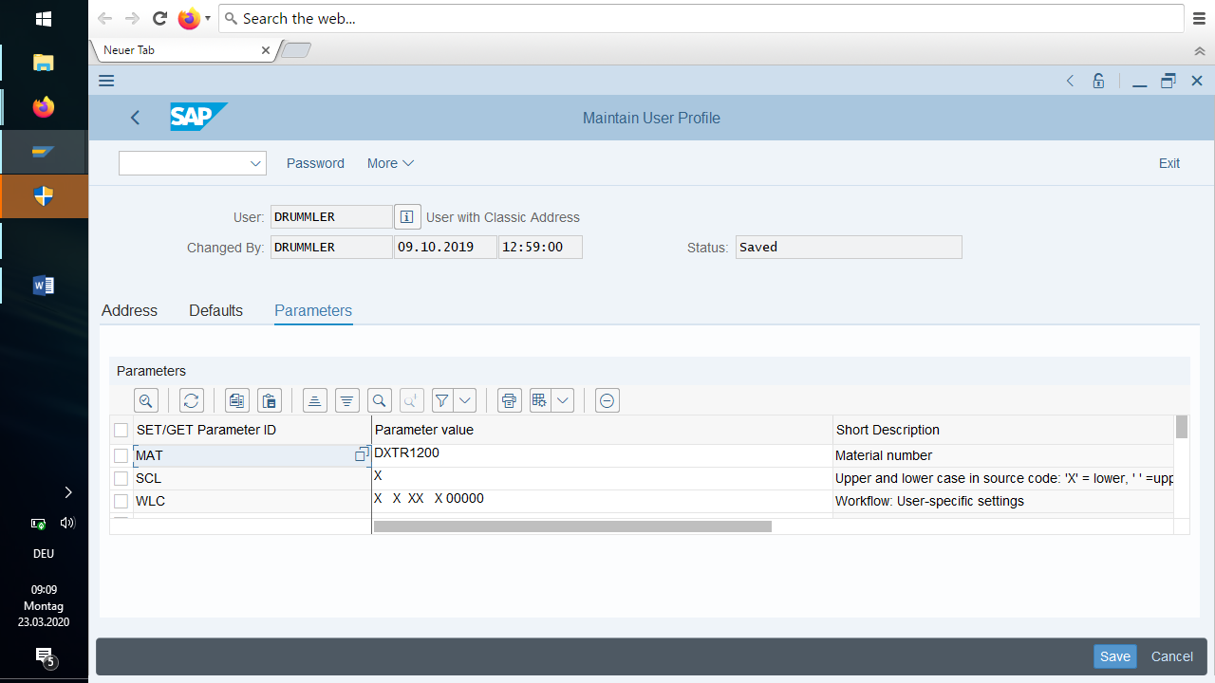

You can set default values if you often work with the same object via the Parameter ID.

The parameter id of a control field you find with F1 in the field and then Technical Information:

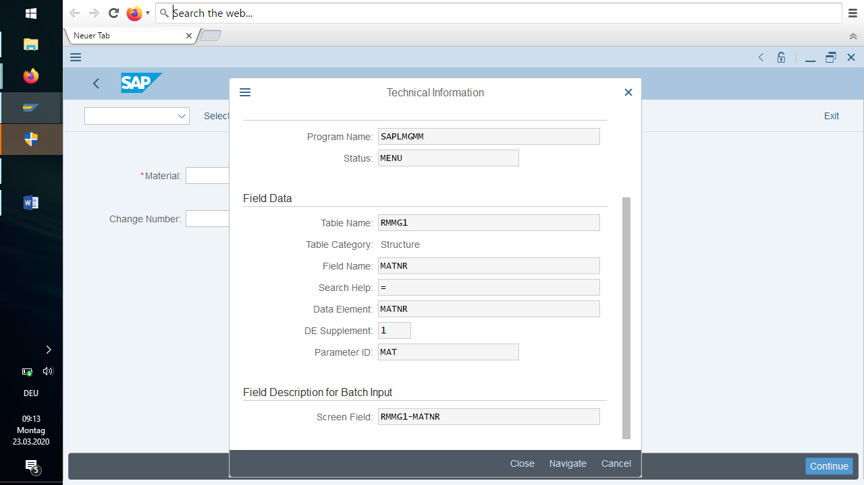

Here you see that (all) control fields material number have the parameter id MAT. And in your user data you set it to DXTR1200.

## Help functions

The *help function* provides information about the application components of the SAP System and explains how to use them.

*The Help* menu contains the following entries:

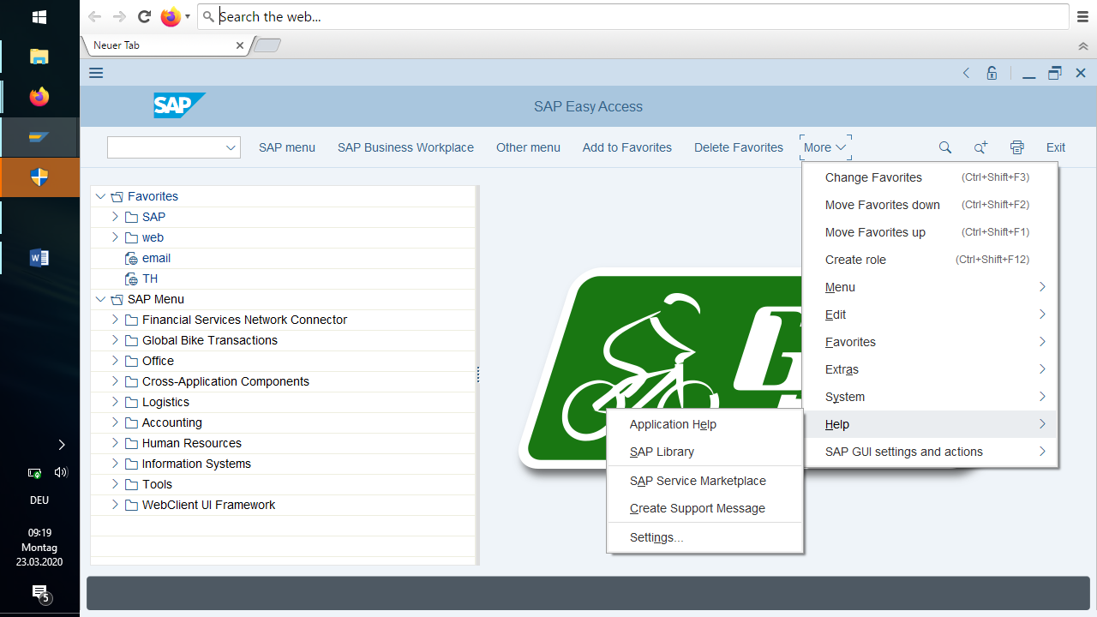

### Application help

Context-sensitive help that you can call from any SAP component.

You use the application help to obtain comprehensive information that goes beyond the field help. You can call the application help directly from an SAP component. You will then be taken directly to the help relevant to your area. The field help explains how to fill in a particular field on an SAP screen. Application Help contains instructions or information that you need to run an application.

### SAP Library

The SAP Library contains extensive online documentation on all SAP components in HTML format.

After you have called the SAP Library and selected an application component, a tree structure appears on the left side of the screen­. This tree structure corresponds to a table of contents for the library. The table of contents reflects the structure of the component hierarchy.

## Help for fields

Place the cursor on the field for which you want to display help and press F1 .

A dialog box appears with help information on the selected field. Optically highlighted terms in the help text refer to definitions in the online glossary or to other information about the respective term. To view this information, click on the desired term.

In addition to field help, you can access application-specific and technical information.

## Help for input values

When you start entering data in a list field it shows you at once all values starting with the entered values:

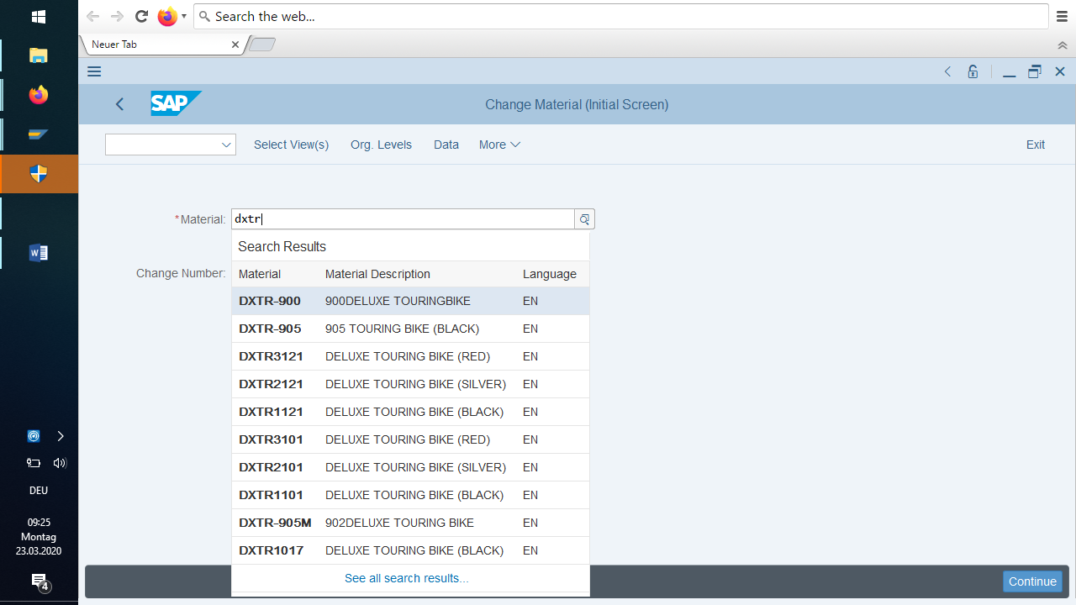

You can display a list of possible input values for many fields in the SAP System. You can select the desired value from the displayed list and transfer it to the input field. However, this input help option is not supported for all fields. You can only see whether the help is available 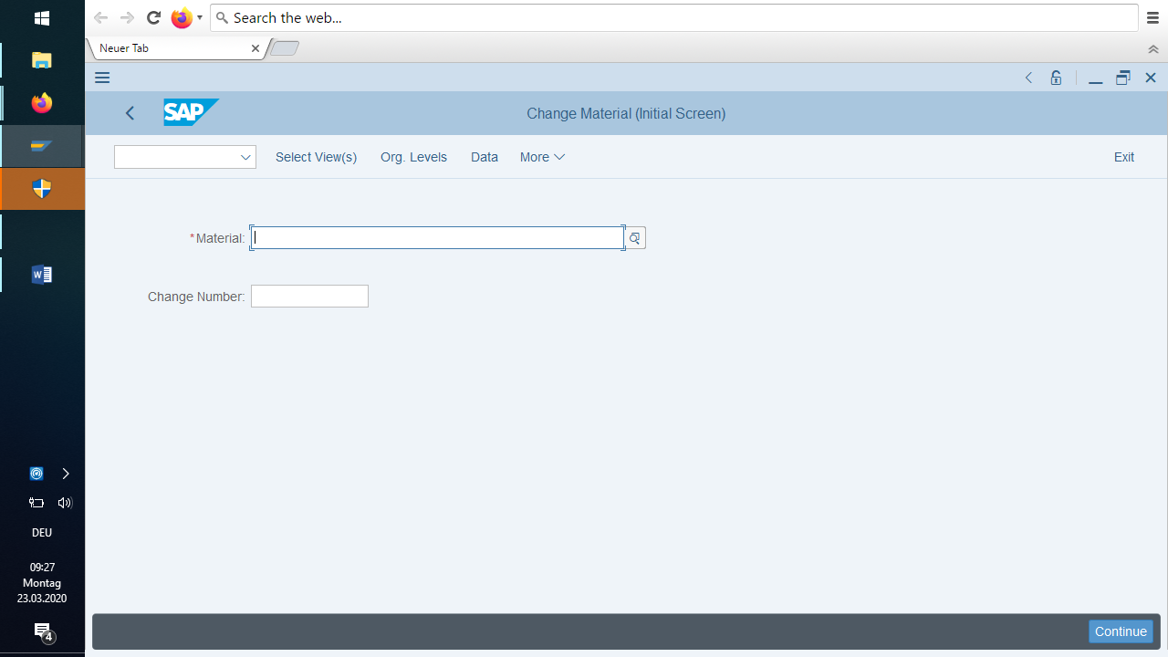

by positioning the cursor on the input field. If input help is supported, the input help pushbutton appears to the right of the field.

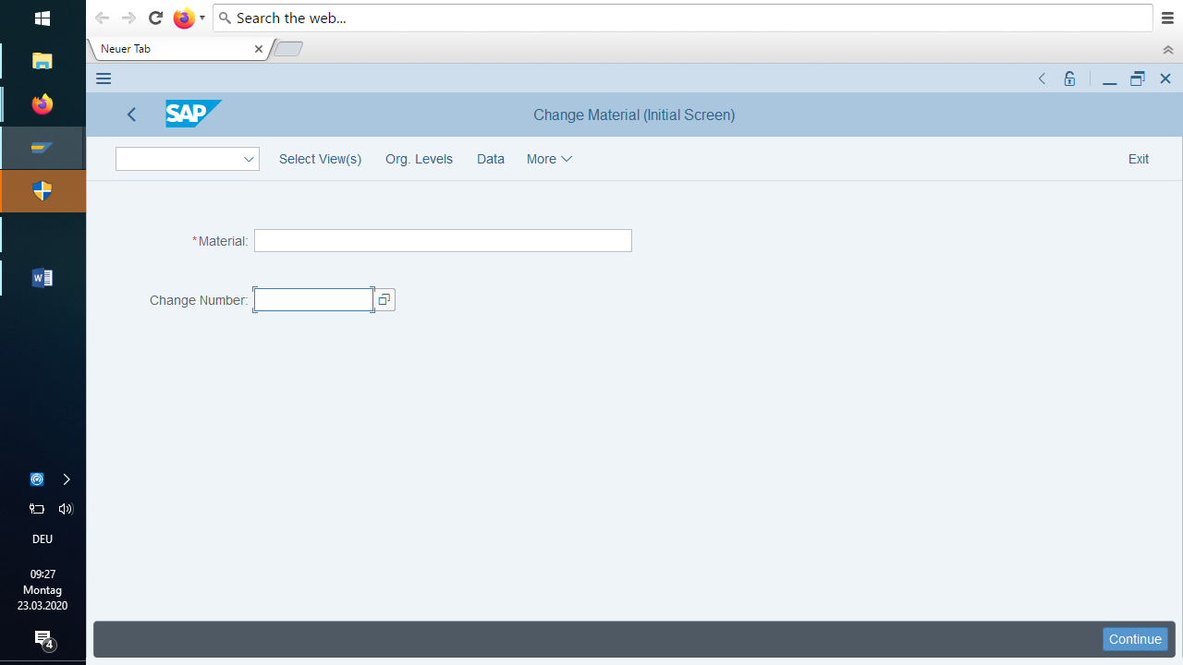

Position the cursor on the required field.   
The possible entries pushbutton appears to the right of the field.   
If the Possible entries pushbutton does not appear, this type of help is not supported for this field.

Click the possible entries pushbutton. You see a list of possible input values.

It’s also possible to do it with **F4** in the field.

Set the pointer to the desired value and double-click to select it. The system inserts the selected value in the field.

The list of possible field values can be quite long. You can restrict the number of field values before clicking the Possible entries pushbutton by entering only the first character of the value and the wildcard character (\*) for the generic search. For example, if you enter k\* in a field, only the values beginning with **k appear in the** list.

Place the cursor on a field that supports possible input values. As soon as you position the cursor on a field with a list of possible input values, the possible entries pushbutton appears to the right of the field.

Enter the first character or several characters of a value followed by the wildcard character \* (asterisk).

Click the possible entries pushbutton. The system displays the hit list with the possible input values.

Select the required input value by double-clicking it. The system inserts the selected value in the field.